Influence of the avian community on Tahiti’s soundscape

Introduction

Island ecosystems & French Polynesia (env description)
Colonization and age of this island, natural vegetation type
Island ecosystems are biogeography defined by two main traits that are isolation and small area, causing together species‐poor insular communities (MacArthur & Wilson, 1967). This native community has been shaken with the first polynesian arrival. Importing the first exotic species, such as Gallus gallus, Rattus polynisiensis or even pigs.

Island ecosystems, Tahiti theatre of exotic species introductions
European colonisation imported larger patch of exotic species that are not that old and turned these insular ecosystems into highly introduced species ecosystems. The reasons are numerous, from the anthropic sides with human colonisation, agricultural development and large transport traffic. And environmental sides, with evolutive-loss of competitive characteristics, small areas.
These places are so victim of ecological changes due to this ecological invasion and has usually high impact on the native community. This is currently true, and biological invasion will continue to impact island ecosystems, supported by other massive threats such as climate change or anthropization process (Lenzner et al., 2020).

Bird introduced to Tahiti:
In this misfortune, these ecosystems, as French Polynesia in our case, are known to offer opportunity for the study of invasion processus and their impacts, that on different levels. Indeed, they are good environments to work on invasion ecology, and study invaded ecosystems, with simple avian community supporting high proportion of exotic species.
The first exotics bird species has been introduced with the arrivals of the first Polynesian. Firstly, the red Junglefowl for meat consumption was introduced. Then during the XIXe century, were introduced by the European the rock dove and the Swamp harrier to prevent rats’ expansion, the red-browed finch and the chestnut-breasted mannikin. Then the Common myna between 1908 and 1915, the common waxbill between 1908 and 1919. The Crimson-backed tanager and Silvereye in the 1930’s, the zebra dove in the 50’s and the red-vented bulbul in 1970. These species well-dispersed across Tahiti and are also distibuted on the others island and archipelagoes. Exotic community composition varies within the others islands. Finally, more recently the black headed weaver has been introduced to Tahiti, still, it’s population is more localised around Tahiti’s airport.

Explication of soundscape
The soundscape encompasses all biological, geophysical, and anthropogenic sounds in an environment and serves as an important communication medium for the biota. The ecosystems-type studied the most concern terrestrial, marine, fresh-water and human-dominated soundscapes (Turlington., 2024). Since this publication, new habitat and sub-ecosystems may have been studied, also the current methods to work on soundscapes should have shift. But at the time of this study, the method to work on the soundscape is mostly using acoustic indices (74.3 %), followed by manual methods (23.8 %) and call recognisers (14.9 %). Across publications using acoustic indices, 61 unique indices were used in totals: (Turlington et al., 2024).

Sounscape pattern also fluctuates within the habitat structure, has instance, complexed densed vegetation can attenuates songs propagation.
Explication Niche partitionning
Vocalizing species occupies a section of this soundscape. The concept of acoustic niche have been applied to describe the acoustic spaces available for a species. Indeed, a native bird community for example contains it’s set of vocalizing species, normally separated in frequency range and time to avoid masking. But, adding introduced species in the acoustic space may creates competition across species, potentialy leading to the concept of niche partitioning within this native-exotic avian community, and may create competition…

Avian exotic species soundscape impact
As highlighted by several studies, invasion and urbanisation gradient can play a role in shaping avian community composition (Rogers et al., 2021). So, the presence of these vocalising exotic species may also modify the acoustic community and their pattern. Soundscape’s modification may impact the communication between native species indiviuals, and so change their occupancy, distribution and behaviour.
Species interference is expected to affect acoustic signals more strongly than, for example, visual signals, since acoustic.
Bird invasion process modifies the soundscape. First new avian species, bring vocalising signals in the invaded soundscapes, and so acoustic interferences. This new species interference may affect acoustic signals communication, since they signal transmit over longer distances and thus can easily mask each other (Wilkins, Seddon, & Safran, 2013). Plus, higher number of vocalizing bird species has been shown to correlate with the detection of more background noise. This noise can be described as acoustic interference, and so potential interspecific competition for acoustic signalling space, compromising communication range. (Robert et al., 2019).
Therefore, species whose acoustic signals are similar to competitors' one may either become excluded from successfully signalling at a particular time or frequency, or may employ vocal compensation to partition their acoustic space to minimize competition (Tennessen et al. 2016).
Current avian composition in French Polynesia is unique compared to continental community. Biological introduction shapes their composition, and fewer native bird species is found on Tahiti rather than exotics one. That is for richness, but also for abondance. Plus, this introduced species can be very vocalizing and ay dominates the avian soundscape with their vocalization.

For instance, Common Myna, which have been associated with the decline of native bird community (Grarock et al., 2012). This highly vocalising species may impact the avian soundscape community. These changes could be highlighted using acoustic indices.

The use of ARU and acoustic indices in ecology:
The uses of ARU and PAM methods is still a field in development (), they are used to run acoustics indices analysis on vocalising species, to acknowledge activity, occupancy and densities (Marques et al., 2013). They have been used to work on a large variety of taxa, with a wide spectrum of assessment methods and goals. They also have been used to work on avian community in urbanised ecosystem (Song et al, 2025).
Passive acoustic monitoring is used to quantify efficiently biodiversity. These are non-invasive, autonomous and usually omni-directional to capture bird activity pattern over short or long period of time (Marques et al., 2013). The usual steps for these kinds of studies are schematising hereafter (Gibb et al., 2019).

Bias are obvisously present with this method. Overlapping signals are common with the uses of automatic recorders, some vocalisation of animals can be masked by geophysical sounds or anthropogenic noises (Pijanowski et al., 2011). It is even more important when working on urban systems using acoustic recorders units, making results from acoustic indices less accurate (Brad-Lawrence, 2023). As PAM is still limited in its range and can only detected vocalising species, in the right place and time (dependent on the designed program of the ARU’s.

Acoustic indices variability in studies
Acoustic indices are efficient metrics that extract and condense acoustic information into single integers which are used to assess the acoustic component of ecological communities (Turlington et al., 2024). Around 61 unique indices have been used to work on the soundscape ( ). It is the main method to study the latter, they differ due to their preliminary goals of study and their calculations methods such as frequency, amplitudes, calculations
Although acoustic indices show great promise for standardizing the analysis of acoustic surveys, the complexity of acoustical conditions necessitates a careful examination of the relationship between an index and the underlying process of interest (Gasc et al. 2013; Fuller et al. 2015).
Indeed, many indices are highly sensitive to site-specific environmental and temporal differences in vocalising animal community composition or nontarget sound levels (Bradfer Lawrence et al., 2025; Staaterman et al., 2017). As different ecosystems hold distinct biotic and abiotic properties (Gibb et al., 2019) and will likely host unique biota and physical structures that impact sound (Gaudon et al., 2022). It is therefore difficult to directly compare acoustic index values between sites and surveys, which limits the reliability of indices in PAM studies that span multiple localities, dates and habitat types. (Gibb et al., 2019).
The main goals for most of these indices and their declinations (Hutschenreiter et al., 2025) regarding the hypothesised link between acoustic diversity and biological diversity, and the studies shows quite variable and contradictory results between and for the same indices (Song et al.,2025) (Eldridge et al., 2018).
Studies results needs to be compared to assess these fluctuations. However, the lack of standardised methodology in ecoacoustic often limits the consistency and transferability of research findings across studies (Gibb et al., 2019; Vella et al., 2022).
To help in this way, classical indices needs to be used with the same methodology, and findings from study places lacking ecoacoustics assessment are welcome to complete this domain. Island terrestrial ecosystems have not yet been well studied. Island systems compostion in French Polynesia, with a variety of abiotic environmental and anthropogenic factor, plus a unique biotic composition, partially within bird community makes it a nice place of study.

Aim :
Our study aims to discriminate acoustic pattern from a highly avian invaded insular ecosystem. Using common acoustic indices, adequate environmental and anthropogenic factor, comibned to a set of avian community variable.
Step 1: First, the study of the distribution of the native and exotic avian community throughout the habitats of the islands will be conducted, in order to assess if the bird assemblage differs within the landscapes gradients of Tahiti.
Step 2 : Then, our goal will be to acknowledge if these potential community dissimilarities can be notice troughout the avian soundscape. We will study how habitats and bird community factors influence, separately and conjointly, soundscape patterns extracted using acoustic indices.
Step 3 (Bonus) : Acoustic indices are metrics extracted from a delimited soundtrack with different calculation methods to reflect patternq inside the soundscape. As their sensibility differs from one an others, refine intra and inter comparisons between indices for certain variables can be made in a third time. This is useful for relations and methodological purposes.
Hereafters are the main goals, questions and hypothesis made up for this preliminary work.

Goals
1. Assessing the avian community distribution with environmental and anthropogenic variables.
2. Characterise soundscape’s pattern throughout common acoustic indices and their relation with habitat and bird community factors.
3(Bonus). Compare the acoustic indices to emphasise intra and inter differences or similarities for specific habitat and bird community variables.

Questions:
Step 1. What habitat factors can predict avian community distribution, using total and exotic richness, presence/absence of native or precise exotic species?
Step 2.a Can acoustic indices pattern be related to anthropogenic, environmental or diel temporal pattern?
Step 2.b Can acoustic indices pattern be highlighted by avian community factors?
Step 2.c What variables remained important when habitats and community factors are treated jointly, does the avian community affect the soundscape?
Step 3.a Which acoustic indices are best-fitted to characterise or predict habitat or bird community variables and why?
Step 3.b Are PCA adapted tools to describe the relation between acoustics indices or sites recorded?

Hypothesis :
Step 1. Avian community distribution is dependent on environmental gradients such as urbanisation or altitudes. Native or exotic species will not be equivalently found throughout the main habitats defined on Tahiti, as resource availability, biotic competition, suitable environmental niche will partially determine their occupation.
Step 2. Indices value are shaped by habitat's complexity, dissimilar pattern can be found between soundscape from high activity urban sites and quieter, even forested ecosystems. Adequate variables will better predict acoustic pattern. In general temporal pattern of anthropogenic activity or avian activity may be reflected for certain habitat type.
Plus, indices can be shaped by the bird community, as abundant, complexed exotic community can be more vocals, with particularly dominant species compare to scarce native avian community.

Step 3. Some acoustic indices sensitivity of calculation will make them perform better than others to predict certain variables. PCA will highlight relations between indices, that aims to shows similar variations or opposite patterns. It may also group similar sites defined by well predicted variables.

Here, we put a foot in acknowledging if monitoring biodiversity through common acoustic indices can be adequate in highly avian invaded places and within an island ecosystem. First, our aims is to describe the distribution of the avain community within the different landscape of Tahiti. Second, to try to find the same potential pattern in the soundscape, taking into account the same bird community and environmental variables.

Methods

Island of Tahiti
Tahiti is a tropical volcanic island. It measures 1,042 km2 and reaches a height of 2,241 m. (Monnet et al., 1993).
The valleys inside Tahiti are regularly distrbituted on the mainland and the peninsula of Tahiti. They are demarcated and start at the level of the central peaks of the ancient volcanoes.
Urbanisation as taken place mostly on the coastline of Tahiti, but is unevenly distributed from the west of the central island to the north-east of the peninsula. With still, fewer construction on the north side of the island.
The entrance of the valleys are so more or less occupied and accessible.
Big anthropisation
Places more or less degraded with a gradient to the city.

The avian community of Tahiti follows landscape gradients such as altitude or vegetation type. But here, the native and exotic avian community is mostly shaped by anthopisation. As native species are nearly always pushed out of urbanized areas, and so restricted inside the valleys and hillsides. Whereas exotic species are mainly located in constructed areas and valley’s entrance.

An island with a large proportion of exotic species, and still several native species present

Bird community
DIre que c’est highly invaded and that is very interesting car not very common.
The native bird community composition for Tahiti consist of marine and terrestrials bird. Marine birds are passing most of their time off-short, but nest in trees or coconut trees more or less deeply in the valleys. For terrestrials bird, two species are more widely distributed in forested areas (Ptilinopus purpuratus, Todiramphus veneratus)and limited by elevation gradients. While two others are restricted in few protected valleys (Pomarea nigra) or more restricted and spare vegetation type (Acrocephalus cafer). The latter are threatened by extinction and are registered as critically endangered (CR) and vulnerable (VU) respectively. Other species, such as (Hirundo tahitica) and (Aerodramus leucophaeus) are also present. Also, a migratory bird can be found in Tahiti, as (Urodynamis tatensis). As these species are dependant of forested landscape, their repartition has been limited to less accessible landscape and so constrained to valleys and inner spaces of Tahiti. Nowadays, no peripherical spaces of the main islands of Tahiti allowed native species to be found permanently. Terrestrial, water dependant species are aslo found in French Polynesia, this species shows larger distribution for Tahiti and others island and archipelagoes.

On the other hand, introduced exotic species dominates the urban spaces. They can be found in both forested and anthropic areas.
These exotic species do not show the same momentum of invasion process and impact. A large proportion of exotic bird are passerines, but the most abundant and problematic species remains the Common myna “Acridotheres tristis” and the red_vented bulbul “Pycnonotus cafer”. The latter can still be found in great abundance in forested areas closed to urban spaces and not too elevated.

Site selection
The sites and data used in this study comes from the work of Emma Pilleboue, who installed temporary acoustic recording unit (ARU) throughout her internship. After installation, the ARU recorded continuously during a period of several days varying between one full day and five full days, between the 15/02/2024 and 02/05/2024.
In totals, 51 sites of Emma’s work are used for this study. The ARU were located at a minimal distance of approximately 200 meters and were in place following altitudinal or urban gradients in some cases. They were also classified into four main habitat type : Urban (4), Suburban (15), Rural (6), Forest(26). The habitats site are mostly forested landscapes or suburban areas, Urban and rural areas are less represented in the site selection.
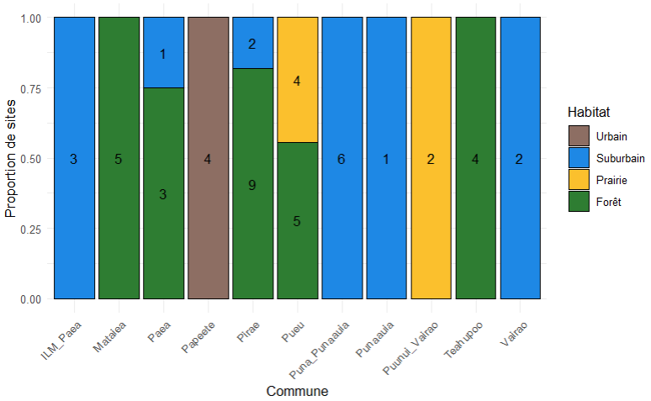

Bird community assessment
Bird point counts of 10 minutes were conducted on two consecutive full days of recordings for each ARU, mainly around 06:00 am on the first and second day after set up. In total, 101-point count were realized, with debut ranging from 05:54 and 06:09 am. One site ‘Punavai 2” lasting shorter than two full days, permitted only one bird point count to be done.
Bird point count can be used to obtain data of species occupancies, site richness and community diversity, for instance. (Gibb et al., 2019). Here we used only, the bird richness, ranging between 3 and 10 species with a ratio of native/exotic species ranging from 0 to 0.5 for a point count. Both point count for a site is fused to represent the total richness of native and exotic bird recorded.
As this were assessed on recordings, no relative abundance of species could be done, as individual recognition cannot be done lacking visual, orientation and distance information. Plus cripticilly vocals species presence, such as swiftlets or swallows, could not be noted as visuals information are lacking.
The total richness find in our point count varis between ten to three bird species with exotic bird representing between 9 to 3 of the present species, while native species occupancy varies between two to zero species
Vocalisation of marine species aren’t the subject of interested, and their presence were very sparse within the point counts, they so, weren’t included in our dataset.
So, in totals, 13 different species are represented inside the point counts, with 10 differents exotic species and 3 native one.
To represent the native and exotic bird community, four different variables are created. Two richness variables representing totals and exotic avian species are calculated. The latter will be treated as Gaussian variables, as we are lacking sufficient species diversity and sites with 0 species for adequate analysis. Plus, binomial variables of native species presence and common myna presence are created to work on native and exotic species separation and study more particularly exotic species of interest. 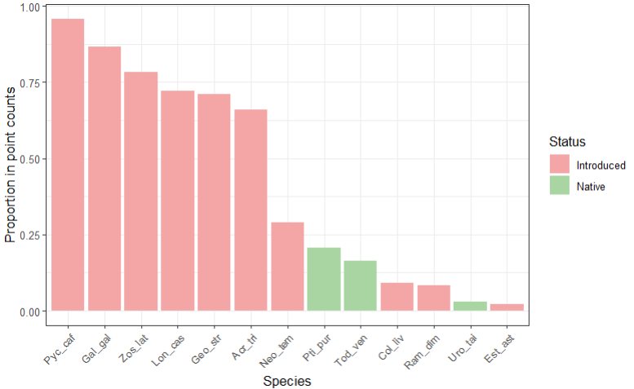
Point count are dominated by exotic species, still about 20% of studied site had some native species detected in one of the two point count realized. 10 exotic birds detected in our site for 3 native one, keeping only nonmarine species.
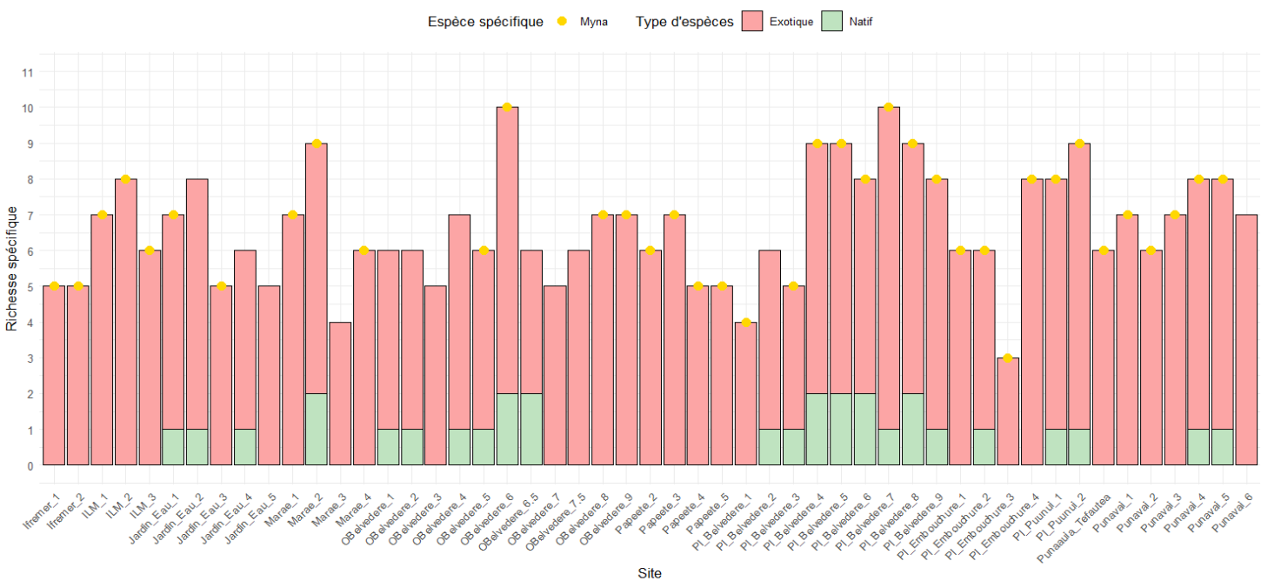
Richn

Environmental and anthropogenic variables
Urban gradient assessment
To have quantitative urban gradient assessment, and not to only used the four habitat type of Emma’s work. A hard surface area index (HSA%) can be calculated for each site location, consisting of the proportion of hard scape area within the 100 m radius surrounding the ARU (Song et al, 2025). This has been estimated using satellite imagery (© Google Earth, version 7.3.6.10441), with handmade polygon inside the 100 m radius to delimit hardscape surface, zone which have been modified by humans and present non-natural material and vegetation.
Each hand-made polygons had a surface value, they were then accumulated for each site, and the proportion between the surface of the 100-meter radius, equivalent to a surface of 31416 m² and the hardscape surface calculated was assess.
Altitudinal gradients assess using Google Earth. Measurements of elevation. Values of altitudes range from 0 to approximately 800m.
For the 51 sites, the hard surface area calculated range from 0 to 88%.
Both factors may delimit bird distribution, native or exotic. Both types may be limited in their elevation, plus native bird can’t find adequate habitat and resources in urban environments. And urban dominated landscape are majorly situated at low elevation on islands.
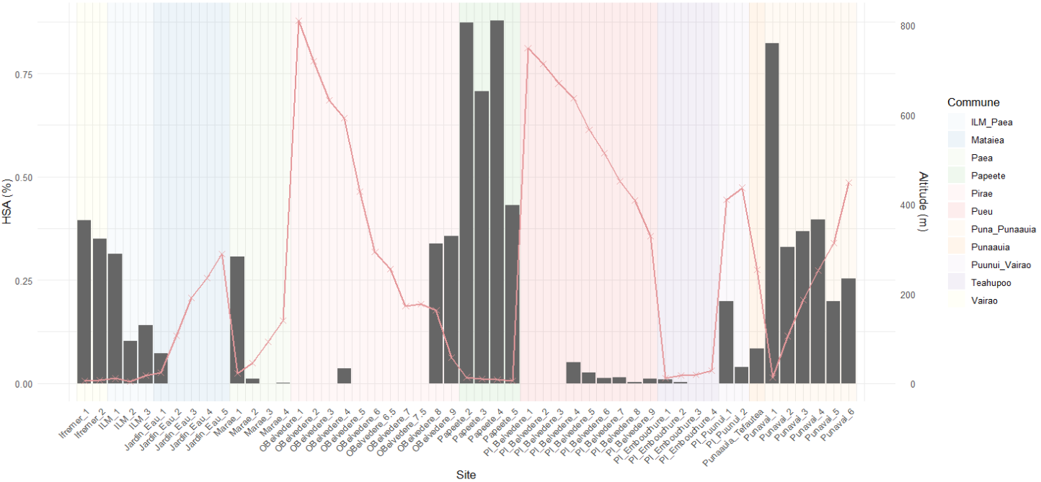
Barplot alt

Daily environmental variations
Azimut and Orientations has been calculated from the GPS coordinate between the centre of the main island or the peninsula and each recorded sites. Azimut obtain vary between 0 to 360° and aims to reflect the variation linked to valley orientation (daily lights, precipitation, clouds). Cardinals point annotations has been used to create the qualitative factor “Orientation”. https://www.vmaths.fr/apps/calculateur-azimut-distance-gps.html
Meteorological data of daily rainfall and maximum temperature have been added to the dataset. Working meteorological stations closest to each of the sites were used solo or combined when possible to try to fit better the potential impact of rain and temperature on soundscape variations. In total 16 stations were used.
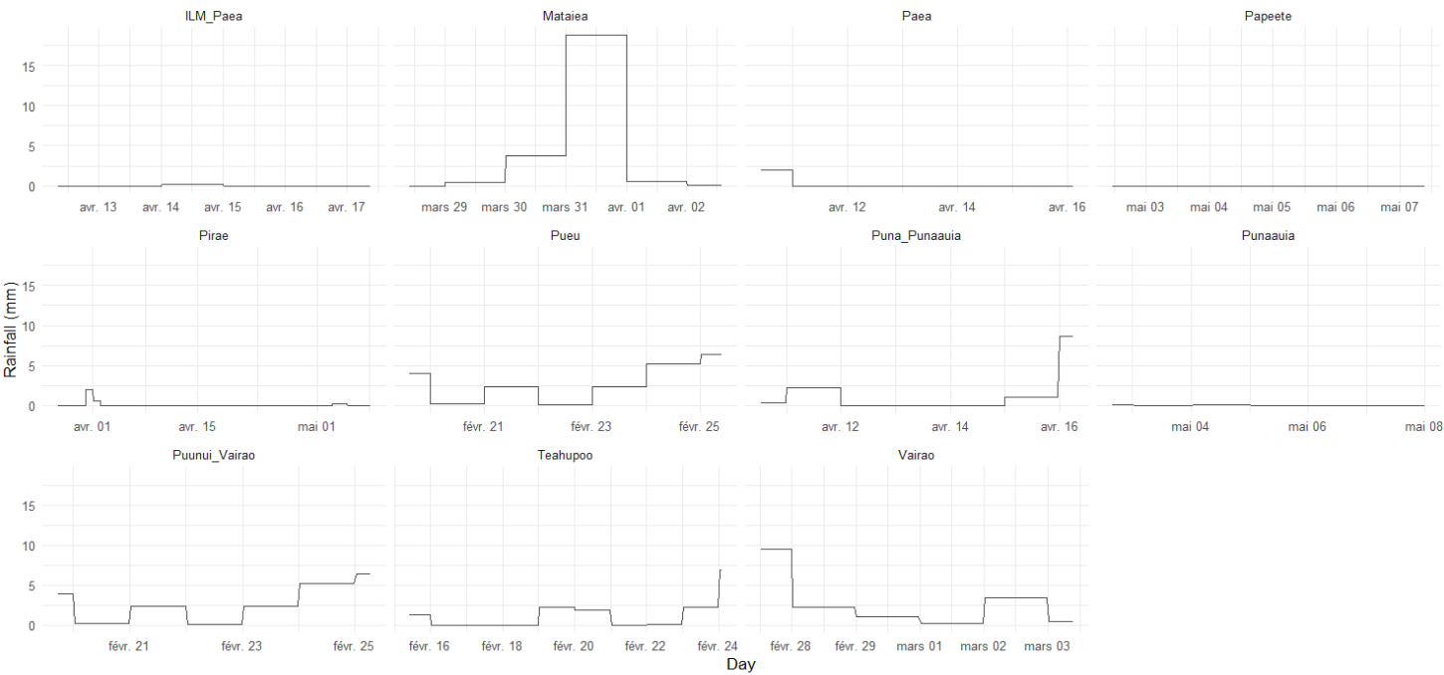
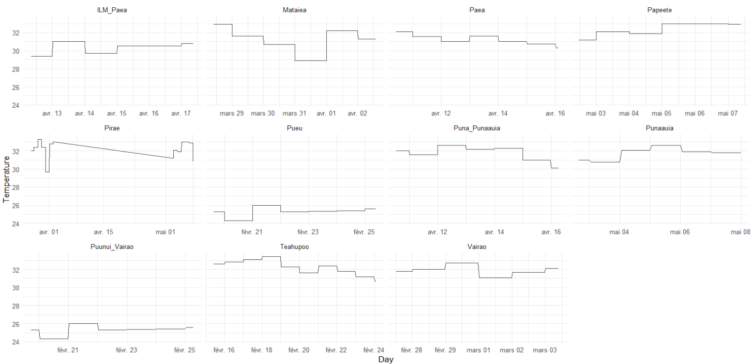
Temporal information of day and hour are extracted from the recording are used to estimate dial activity shift, behaviour adaptations to anthropogenic or natural disturbances (Iannarilli et al., 2025).
To describe the environments, vegetation assessments made by Emma Pilleboue work are used in here. It informs on the percentage of herbs, shrubs, trees and anthropogenic surfaces around each ARU. In complement of qualitatively determined the habitat type, quantitative vegetation percentage are used to separate the habitat compartment in the analysis. 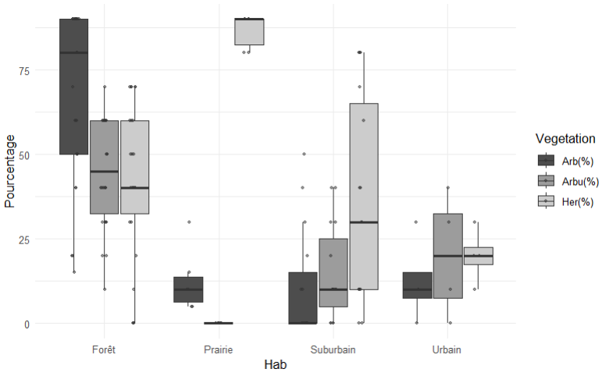
To dig into humans disturbance and urban spaces, proxies of distance from each site to sea, to principal road and to first buildings are used. They may be used are variables, but in complete 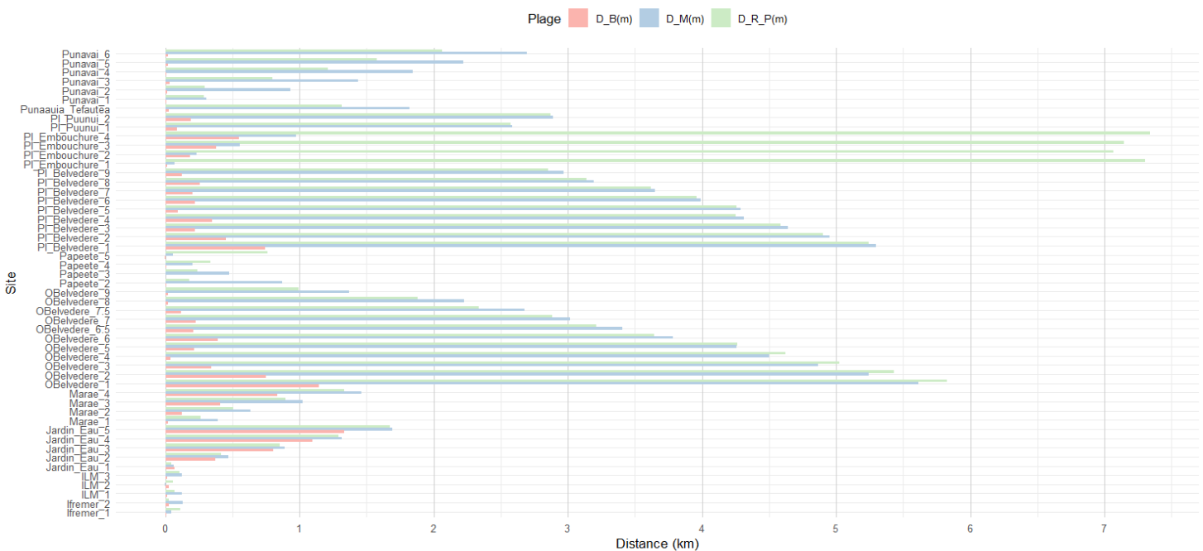analysis are greatly correlated to other factors.
This measuration are done also using Google earth, using the shortest distance to the point of interest (sea, mainroad or building).
Distance

Scatterplot
So, right above are a big batch of environmental and anthropogenic variables that can be greatly correlated between one-another. To have a better view of their relations, hereafter are their correlations.
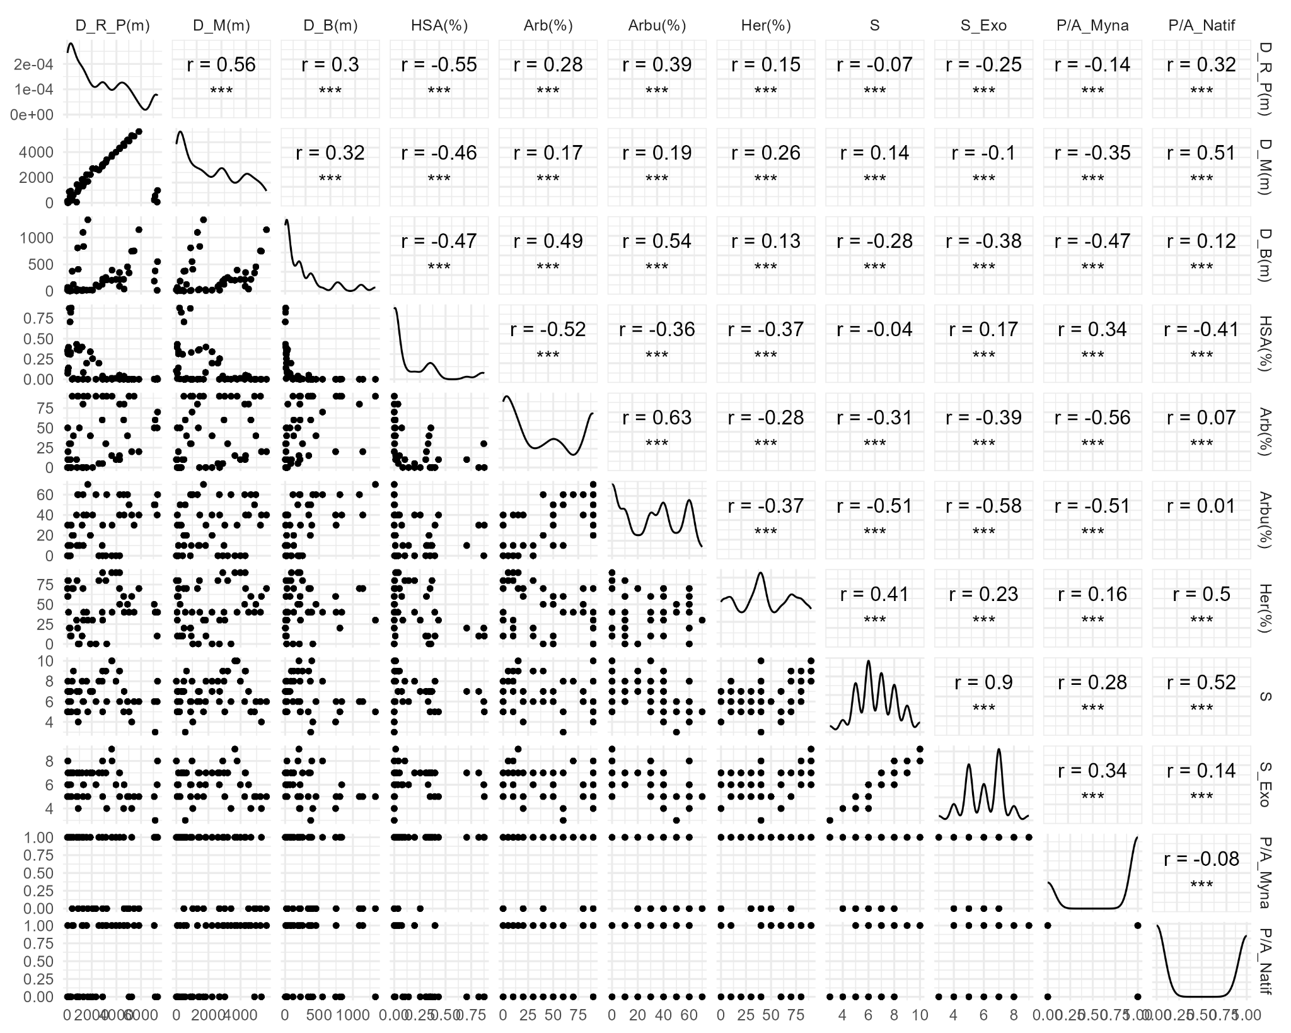

Acoustic Data Collection & Analysis
Continuous sampling methods were used for every acoustic recording unit on Tahiti (n=51). The ARU utilised were Song Meter recorders disposing of 3 or 4 battery placements (ARU ; Song Meter Micro, Wildlife Acoustics, Inc., Concord, MA, USA), for a sampling rate of 32 kHz and a gain of 18 dB. For every site, one hour or 30 minutes waves files were created. In total approximately 242 days of recording have been captured within Emma’s field work, corresponding to 5960 hours recorded.

Acoustic data processing to limit analysis length:
We are working on an analysis between 300 and 8000 Hz to take the important frequency length for bird song, in order to try to limit other biphonic, geophonic/anthropogenic disturbance. (But All bird indices analyse with 512 fourrier transformation.
Two main analyses of the recording’s files were conducted.
First, to have rapid index's calculation, the files were filtered to uses only days recording, as limited night activity is expected for diurnal bird’s species. So, analysis focus on files recorded and ending between 05:00 h and 19:00 h were kept (source), mon choix . Only 5 minutes random sequences analysis per hour permit to facilitate the analysis and processing effort. Files delimited with 30 minutes wave files, were calculated on one file for two, to be comparable with one-hour waves files. With sufficient recording amount, minimal variability and preciseness is lost compare with full file analysis (Bradfer-Lawrence et al, 2019).
This preliminary analysis, was conducted to detect the first pattern inside our recording, while limiting the time of analysis.
Second type of analysis consisted of 10 minutes analysed with night recording kept, this will permit a more complete description and processing of the acoustic pattern observed. Our current modelling and analysis are focused on this dataset.
Six common acoustics indices (ACI, ADI, AEI, BIO, H, M) are being used to limit data processing. This six index gives a unique value per wave file and examine the wav files with a variety of calculation methods making them sensible to different things and pattern in the soundscapes.

Description of Acoustic indices uses.
Explain the groups of indice used here (Assessing biophony mostly for five fiest indices and M, measuring the amplitude of noise of our recordings). These indices which goals aims to the soundscape’s elements are prone to anthropophonic noises, geophony and biophony. Especially while working on biodiversity trough biophonic sounds, acoustic indices are affected to anthropogenic and geophonic noises and sound. (Fairbrass et al., 2017).

For better description and tests, use the website to have basic indices described : https://ecohack.shinyapps.io/Acoustic_Index_Users_Guide/ (Bradfer-Lawrence et al., 2025)

Hyp ACI : Highest value will be in within dominated exotic bird community, as more activity will emerged from this variable’s places, and also due to anthropic noise.
It is calculated as the average absolute fractional change in spectral amplitude, averaged over all frequency bins for the entire recording (Fuller et al., 2015). The acoustic complexity index was developed based on the observation that many biotic sounds, such as bird songs, are characterized by an intrinsic variability of intensities, while human-generated noise is often constant in intensity (Pieretti et al., 2011). The acoustic complexity index has been used to describe avian soundscapes (Farina et al., 2011), relate avian soundscapes to vegetation complexity (Farina and Pieretti, 2014) and describe the influence of traffic noise (Pieretti and Farina, 2013).
Hyp BIO: More disparity between bands within exotics bird places (amplitude between twio bins, I guess, so higher value. Should be more consistent in less invaded ecosystems
Similarly, Boelman et al. (2007) developed a bioacoustic index which was a function of both the spectral amplitude and the number of frequency bands in a sound recording. This index was shown to be strongly correlated with avian abundance in Hawaiin forests experiencing weed invasion. (Fuller et al., 2015)
Acoustic diversity indices have also been developed to facilitate automated surveying of ecosystems for rapid biodiversity appraisal (Sueur et al., 2008b, Sueur et al., 2012).
Hyp ADI: Highest value from anthropic noise dominated, and maybe bird vocalisation dominated, as their will be more saturated in the frequency bands. Lowest value should come from forest places, where vocalisation is less consistent and more disparate, but background noise is still present.
The acoustic diversity index (Villanueva-Rivera et al., 2011) is a modification of spectral entropy and is also calculated using the Shannon index, while the acoustic evenness index uses the Gini coefficient as a measure of evenness (Villanueva-Rivera et al., 2011). (Fuller et al., 2015)
Hyp: H: Places with even frequency band will give higher value.
The acoustic entropy index is one such index and is computed as the product of both the temporal (acoustic energy dispersal within a recording) and spectral entropies (acoustic energy dispersal through the spectrum) following application of the Shannon index (Sueur et al., 2008b). Simulations revealed a correlation between the acoustic entropy index and species diversity and in field studies this index was found to be sensitive to disturbance in Tanzanian forests (Sueur et al., 2008b).
Hyp AEI, saturated places or evenly distributed places will have the lowest value, more intensity difference between two frequency bins will create higher values, maybe exotic bir places will have higher value as less evenly distributed, and forest maybe more consistent.
Hyp M: If it reflect the amplitude, higher amplitude sites, so noisier, should come from exotic bird environments and anthropize sites.

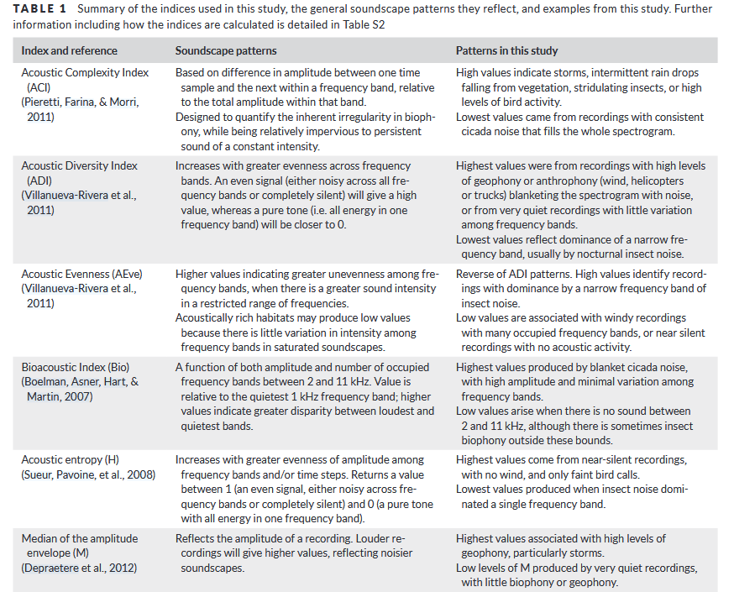
Our classical indices with global trends on Soundscape and the result of their study (Bradfer-Lawrence et al, 2019)

Statistical Tests and Models
We use graphical analysis with linear models to looks at global pattern and correlation between biotic and environmental variables
Same goes for acoustic indices using boxplot and graphical curb and linear models to look at temporal pattern and their linked with biotic, environmental variables.
Correlation matrix for explanatory variables used in the generalized linear mixed models. Collinearity between variables was assessed with the VIF function in R, and variables with a VIF score of greater than 5 were removed before the model was run.
For models, simple linear models and linear mixed effects models were used in majority to work with a bunch of variables, with each indices as responses variables. Trigonometry was also used to work on diurnal pattern.
Genealized additive models were also used to work on temporal pattern.

Goal of this study:
- 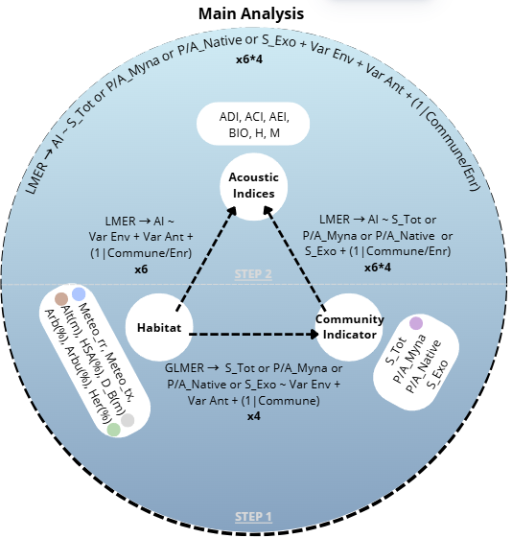

Results

For the overall result of this study, see the document supporting oral presentation “Diapo_Paysage_Sonore_FR”

Richesse totale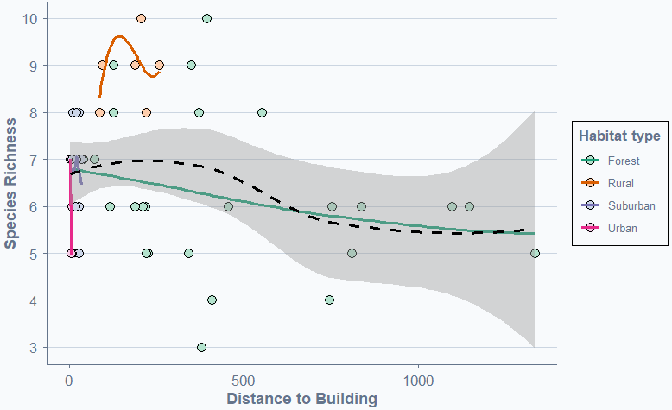

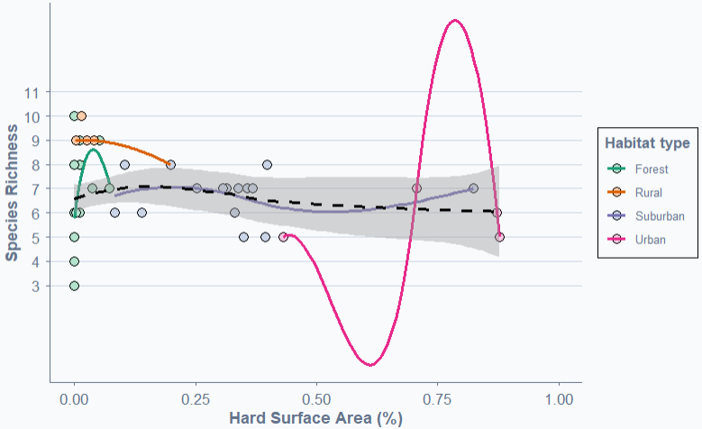
exoitque

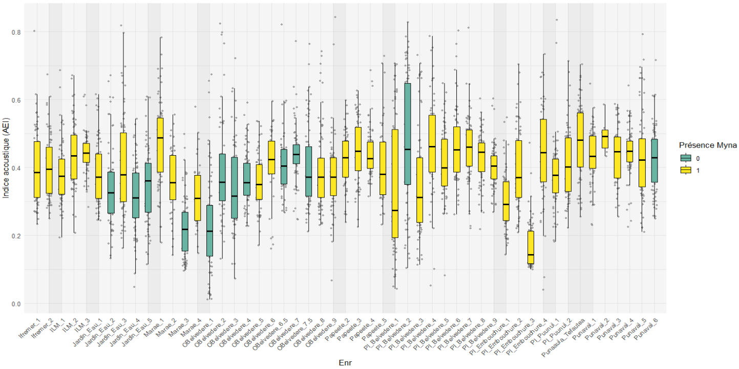

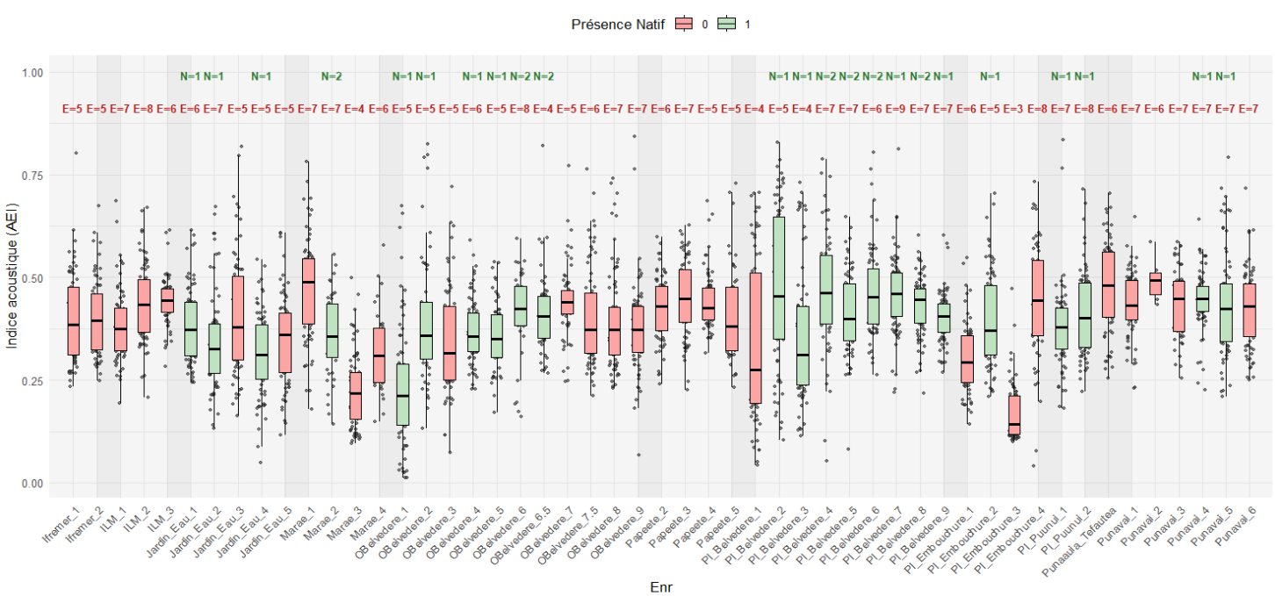
For better comprehension of what fluctuates acoustic indices, variables are categorised by color.

Step 1: Avian community factor x Habitat factor
Recapitulative table SxHab:
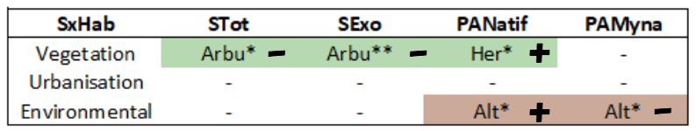

Richness general:
Both richness indices showed significant relationship with vegetation composition of sites. Also, keeping only grass for definition of habitat, distance to building is significant for total richness but nor for exotic richness. AIC value indicate that better fitted models both for total (187,5) and exotic (166,6) richness is done using shrub percentage. Still, better fitted models for vegetation variable need to be adapted with acoustic indices as response variables. The estimates of the model for total and exotic richness and habitat variables was 6,647 and 6,059 respectively. In both cases, linear mixed models has richness value declining of less than 1 bird species as shrub cover increases (tab ). Also, when only keeping grass cover, higher distance to building decreases total and exotic richness.
Exotic richness in total anova have better significant value of shrub(%) predictor for total vegetation (**) than total richness anova (*).
Estimate of the intercept indicate a weak influence of native species, as total richness estimate of richness is 6,647 and 6,059 keeping only exotic species, showing a weak ipact on naitve species on calculation.

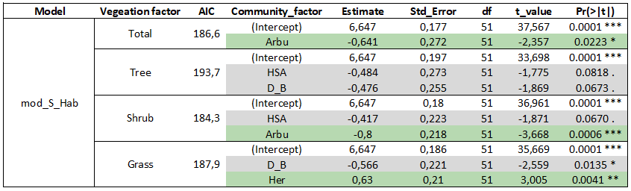
LMM SxHab:

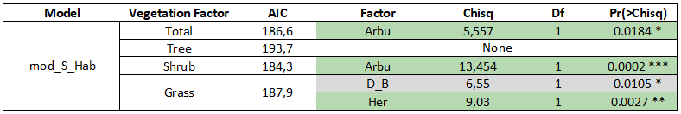
Anova SxHab:
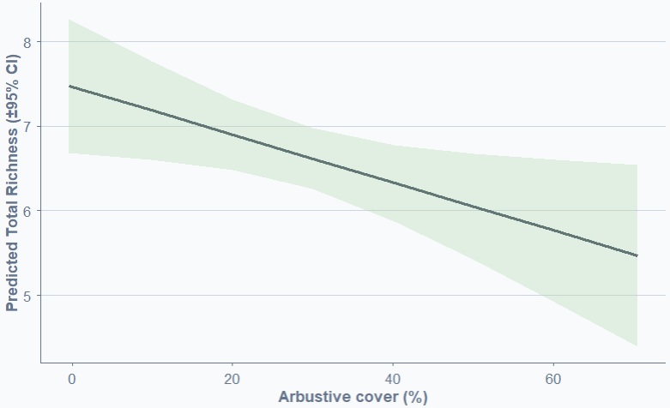
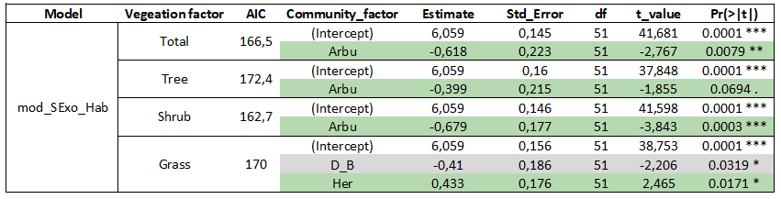
LMM SExoxHab:

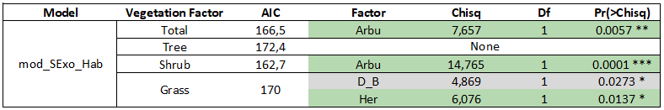
Graph: SExo x Arbu
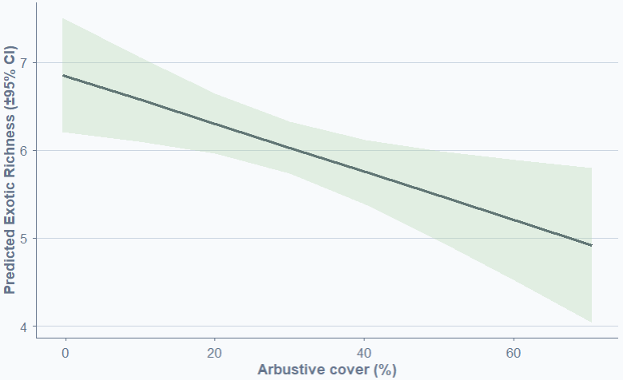
Presence absence General.
Response variable Native and Myna are binomial (1-0) and are so threated with glmer (Binomial, link = logit). Here, model summary show significant and nearly significant value (<0.1) to have a better global view on potential relationship between bird community variables and landscapes variables. Also, significant variables with anova will be better discussed than les significant one.
Here for both presence-absence models, AIC value indicate than best fitted model is done keeping grass for vegetation cover (PANatif = 53,6; PAMyna = 42,6). Signifant relationship variables for native species presence are altitude and urban variables (Distance to Building and Hard Surface Area). While, Myna presence is linked to Altitude and temperature. Estimate value for altitude indicates a positive relation for native species presence with higher altitudes (tot = 1,581) and a more consistent presence of Common myna for lower altitudes, near the coastline (tot = -2,661). Urbanisation also plays a significant negative role for native presence (D_B = -1,344; HSA = -2,568 with grass as vegetation type), whereas no link are revealed with myna presence. But, temperature seems to play a role for Myna presence absence, as the data used represent a mean for a few days with station data more or less representative of the site, no strong hypothesis can be made at this level. But higher temperature indicate less myna presence which is biologically coherent.
Best fitted models of Myna presence shows weak positive relation with grass cover and negative relation with rainfall.

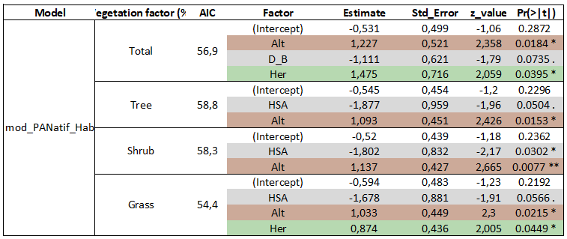
GLMM PANatifxHab:
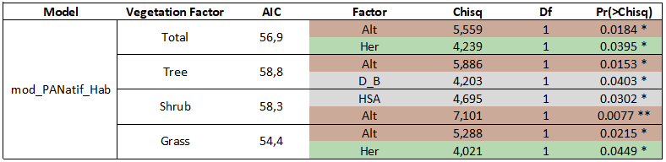
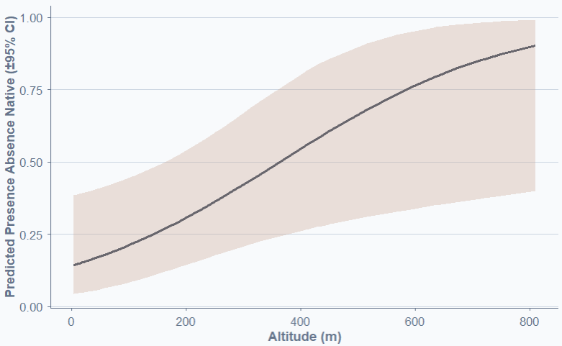
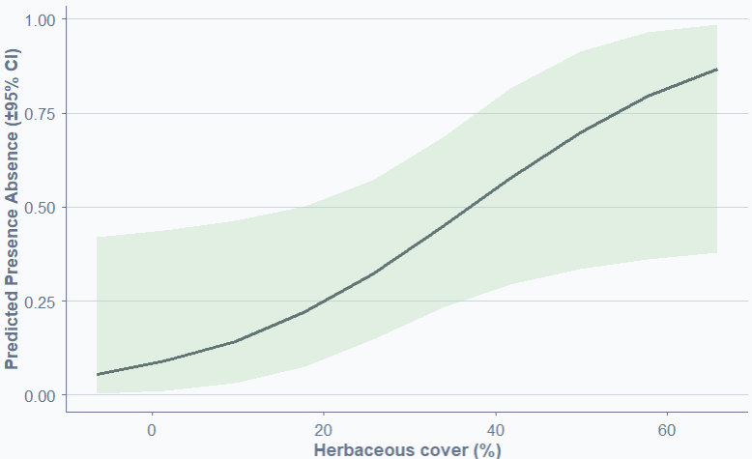
Anova PANatifxHab:

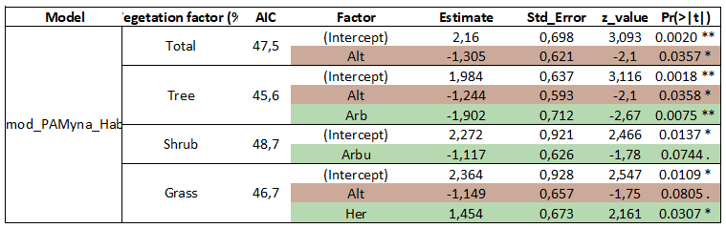
GLMM PAMynaxHab:

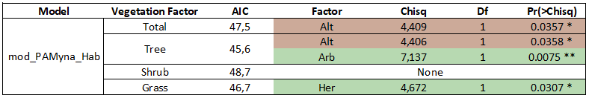
Anova PAMynaxHab:
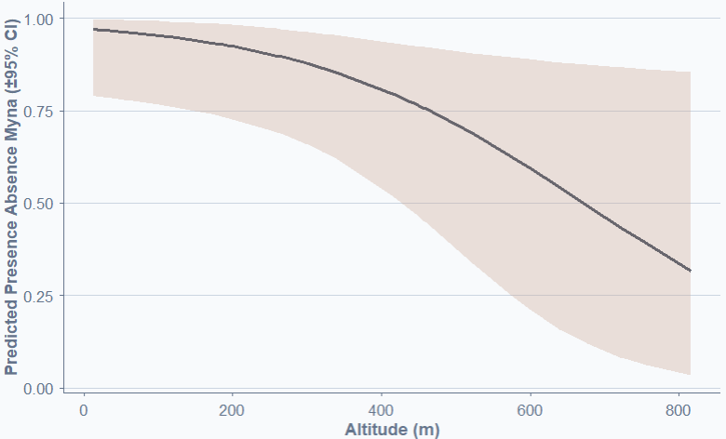

Prédiction temporelle:
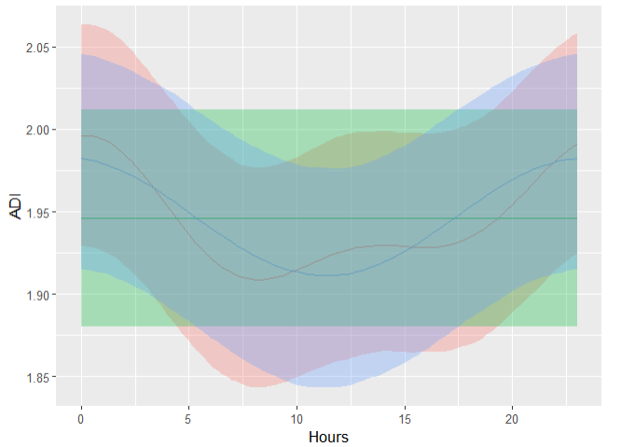
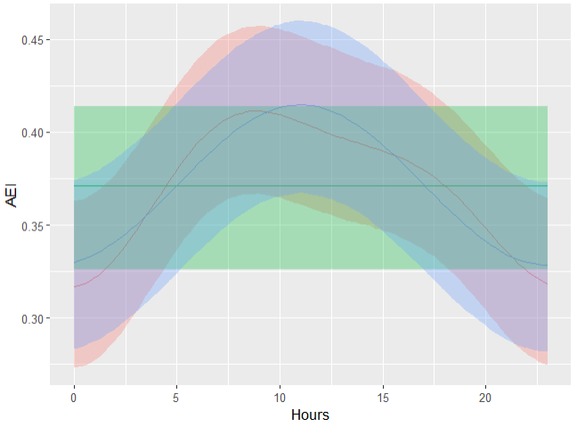
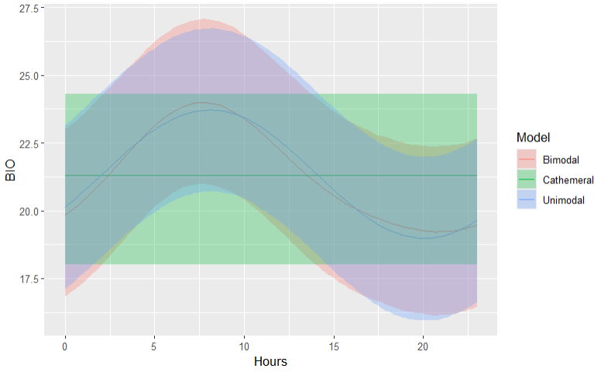
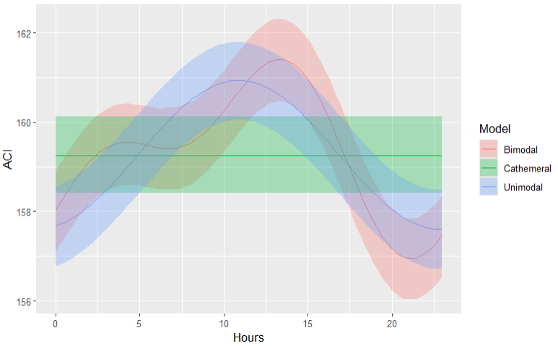
Modelisation of diurnal pattern has been tested for forest habitat using 10m recording files. Graphical representation of cathemeral, unimodal and bimodal activity pattern for each indices are showed. Then comparison of best fitted models using anova are compiled (tab..)

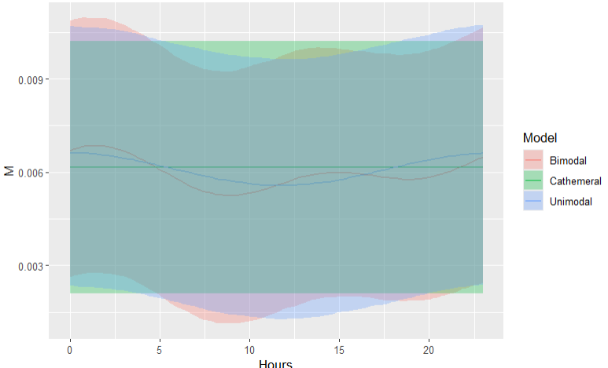
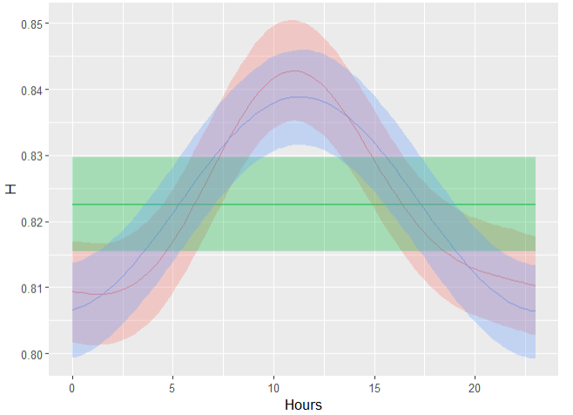

Hereafter is the table compiling the anova result comparing random effect selection with the six acoustics indices. Mainly, each indices are consistent for their best fitted dial activity models, throughout random effect selection. To be noted that the fluctuation of the variance explained are minimal, and may not have an important impact on other variable, they just need to be taken into account.
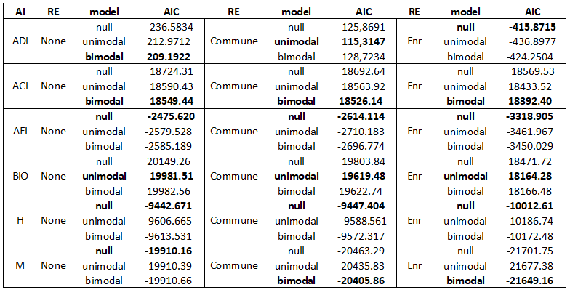Different pattern are showed with each acoustic indices and the random effect used in our study. With complete variables models, diurn pattern factor aren’t affecting others variables relationship. Decisions has been made to keep diurn variable as bimodal for the acoustic indices main models, to take into account the most dataset variance as possible and respect possible dial activity fluctuations.

Step 2: IA x Hab IA x S, IA x S + Hab
Recapitulative table IAxHab:
With models using only habitats factor as predictive variables, the soundscape is not affected equally by our different acoustic indices tools. Vegetation types does not permit to reflect strong differences in the soundscape, only AEI shows a slight relation with shrub cover, trees and grass cover aren’t explanatory with our 6 indices.
Urbanisation factor are significant in two out of six indices. Anthrophonic activity affect the complexity of the soundscape, reflect by BIO and it’s uneven-eveness as showed by the indice H reflecting consistency in the soundscape and so sensible to this type of fluctuation.
Meteorological factor have a greatly significant impact in the soundscape. Rainfall has strong relation with BIO, M and ACI. It’s the only significant predictor of the latter, indicating that rainfall presence affect strongly this indices calculation. Same can be said for M, whiwh reflect the amplitude of the sound, and show that consistent rainfall affect greatly the soundscape decibel. The Indice BIO, is sensible to several types of variables, but rainfal is the only one with great significance, showing that even if this indices reflect easily some variations in the sooundscpae, rainfall has a bigger impact than the rest. Maximum daily temperature also has a great impact, demonstrated with two sensibles indices fot this variable. BIO and M that have reflected the soundscape fluctuation linked to the rise or fall of daily temperature.
Lastly Altitudinal gradient is a significant predictor for ADI, BIO and M. So along the altitudinal gradient, variation in soundscapes has been reflected by three out of six indices. Maybe indicating a quiter soundscape in altitude reflected by the indice M. And more complexity for ADI and BIO in lower altitudes?.
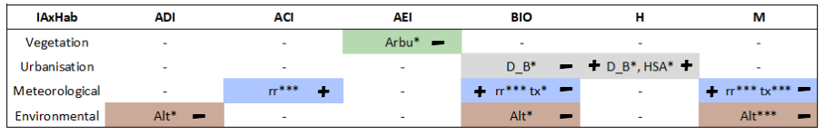
Recapitulative table IAxS:
Here bird community influence on soundscape can be reflected by our acoustic indices. Out of our four community factor, separated between gaussin distributed richness factor, total and exotic. And binomial presence absence factor for native species and an exotic species, the Common Myna. First three indices (ACI, BIO and M) does not reflect variation in the soundscape using only our community factors. Richness factor explains part of soundscape variation using ADI, AEI and H, only exotic richness is signifiant for the latter. AEI is a great tools to reflect the richness variation in our case with the best fitted model for total and exotic richness. Plus ADI also reflects the same pattern with less but still significant relation.
For binomials factors, only common myna occupancy is significantly related to soundscape variation, using the H indices as tool.
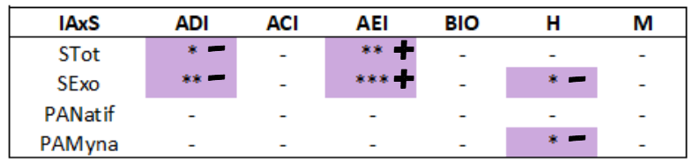
Recapitulative table for IAxSxHab:
For the following analysis, consistent pattern in significant habitat variable can be found for the same indice, which support precedent pattern of the acoustic indices even if some changes are found due to the covariable community factor and model selection. The soundscape is fluctuating with our environment and the variable that we considered reflects the habitat but are more or less reflected by the acoustic tools index used.
The first table represented the models using all three vegetation type, while the second passes a selection for the best fitted vegetation type.
Recapitulative table IAxSxHabtot:
For the community factor, only AEI still reflect a relation between avian total and exotic richness and soundscape variation.
For vegetation type factor, shrub and grass cover can have significant relation with the soundscape, but their link are weak and significant relation changes inside the acoustic index used.
Urbanisation factor are consistent in two out of the six acoustic index. Distance to building role in soundscape is bring out by BIO index, that seems to greatly reflect the soundscape variation link to all environmental variables, except vegetation type. H index reflects the impact of urbanisation cover in the soundscape.
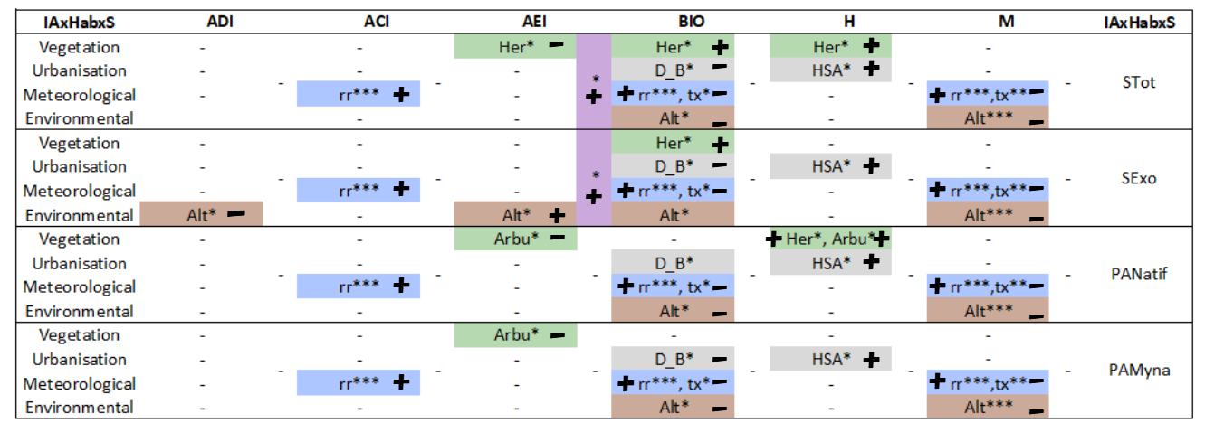
Recapitulative table IAxSxHabam: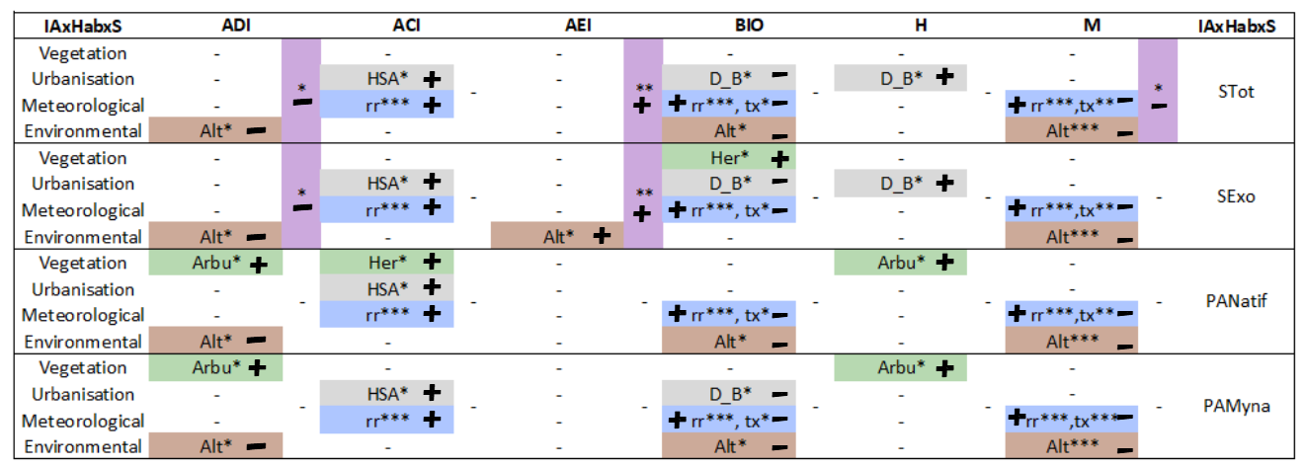
OU
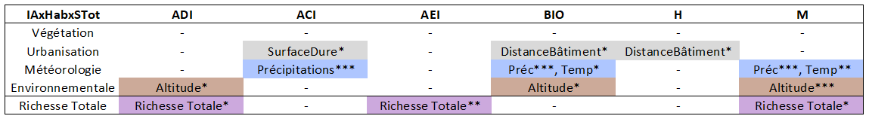
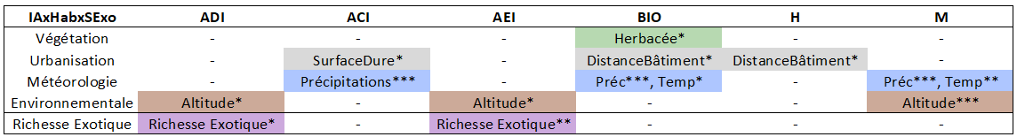
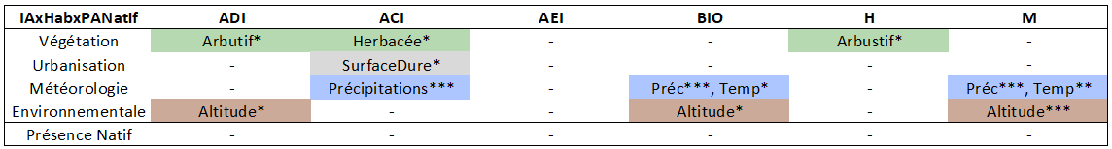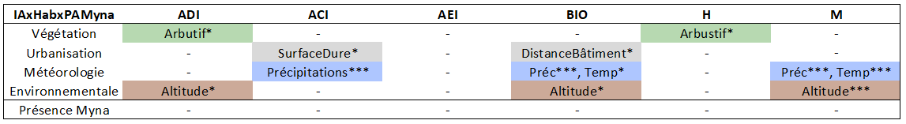
3/6 indices varient avec la richesse native et exotique. L’AEI est l’indice reflétant le mieux les variations du paysage sonore par la richesse totale et n’est pas corrélé aux variables d’habitats La composition de la communauté aviaire influence le paysage sonore
2/6 indices varient avec la richesse exotique. L’ADI et l’AEI restent les indices reflétant les variations du paysage sonore par la richesse.
La présence d’espèce native n’affecte pas les indices acoustiques. Donc influence limitée des espèces natives dans le paysage sonore.
Les indices ne varient pas avec la présence du Martin triste. L’indice H montre une tendance significative avec la présence du Martin en ne considérant pas les variables d’habitats. Mais possible effet de la structure de la communauté confondu avec les variables d’habitats dans les modèles

ADI: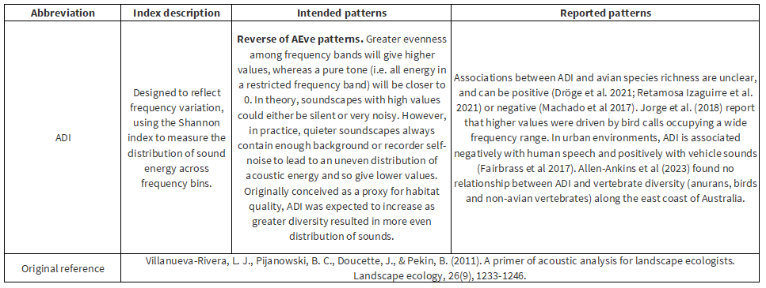
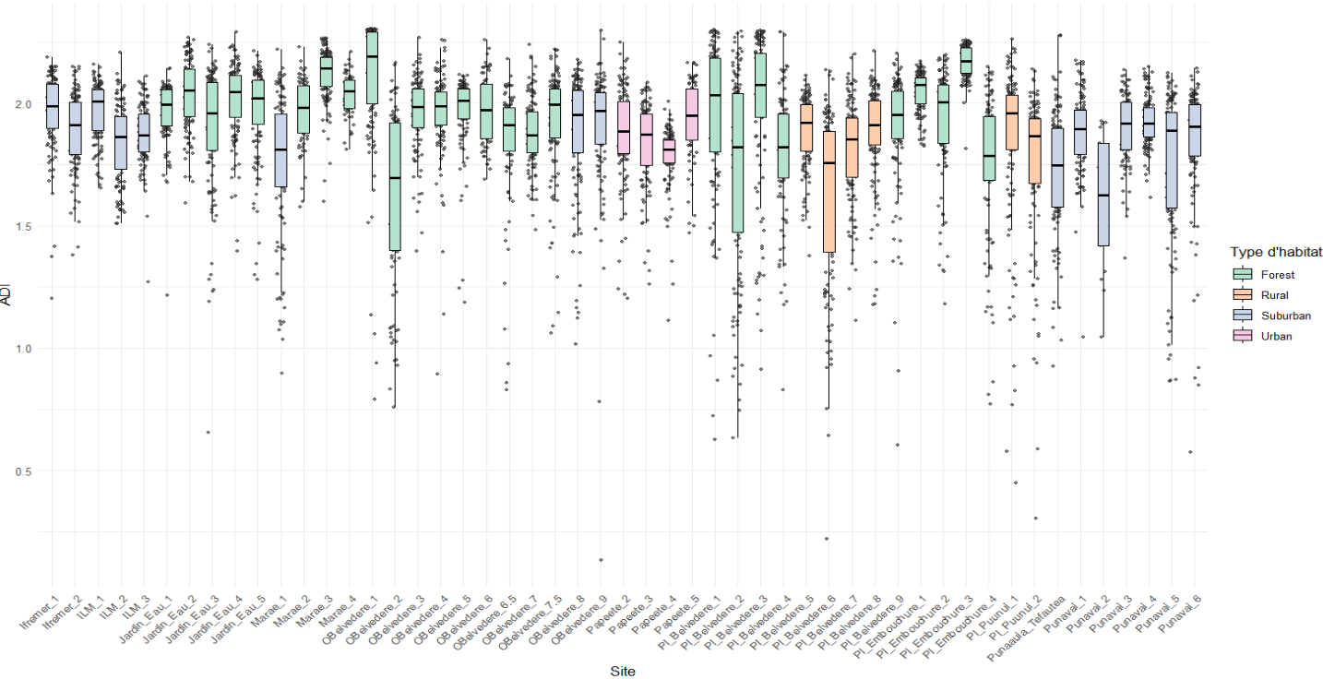

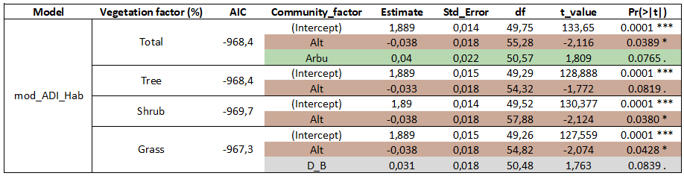
LMM ADIxHab:

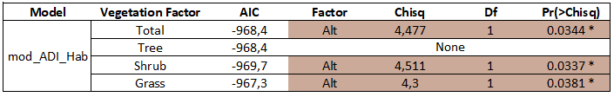
Anova ADIxHab:
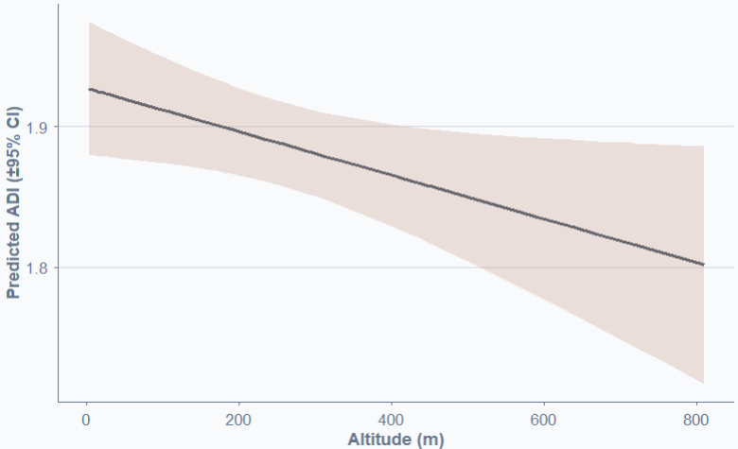
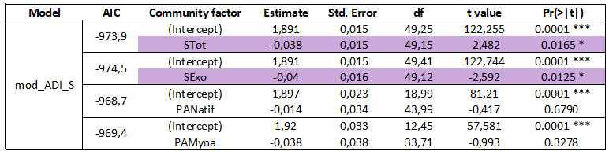
LMM ADIxS:

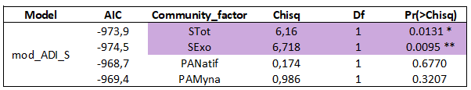
Anova ADIxS:

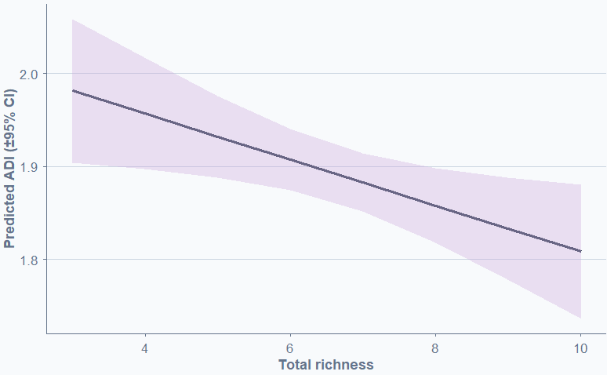
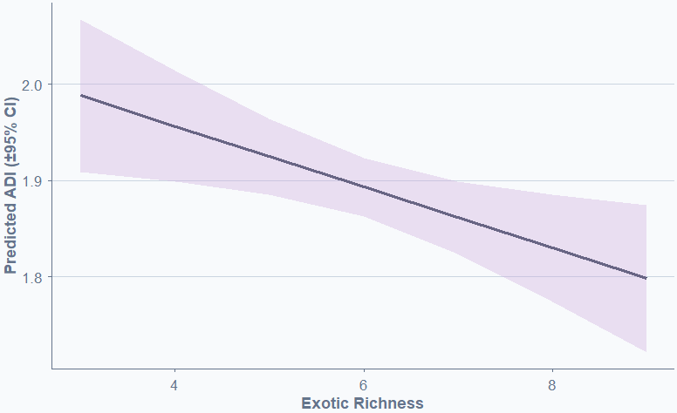
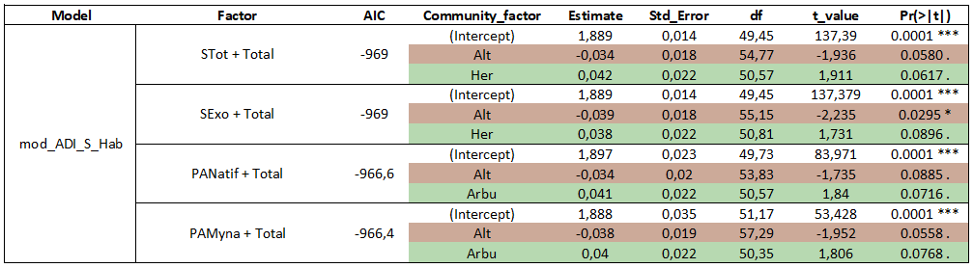
LMM ADIxSxHabtot:

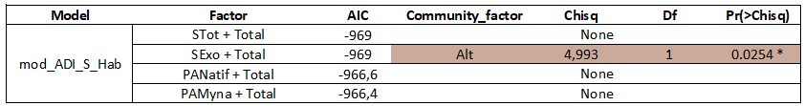

Anova ADIxSxHabtot
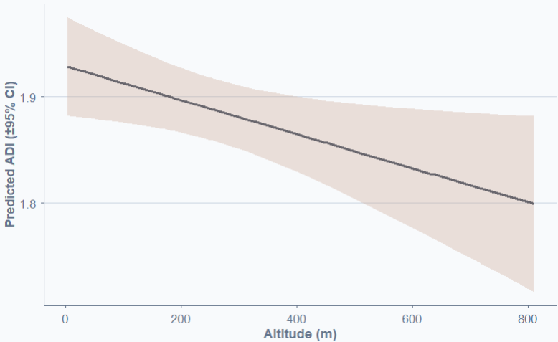
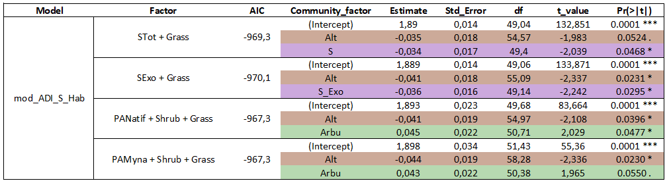
LMM ADIxSxHabam:

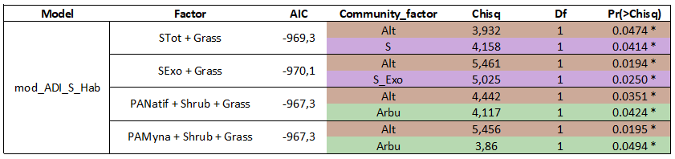
Anova ADIxSxHabam:

ACI:

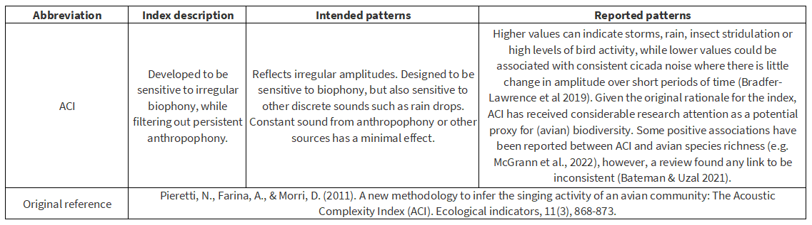
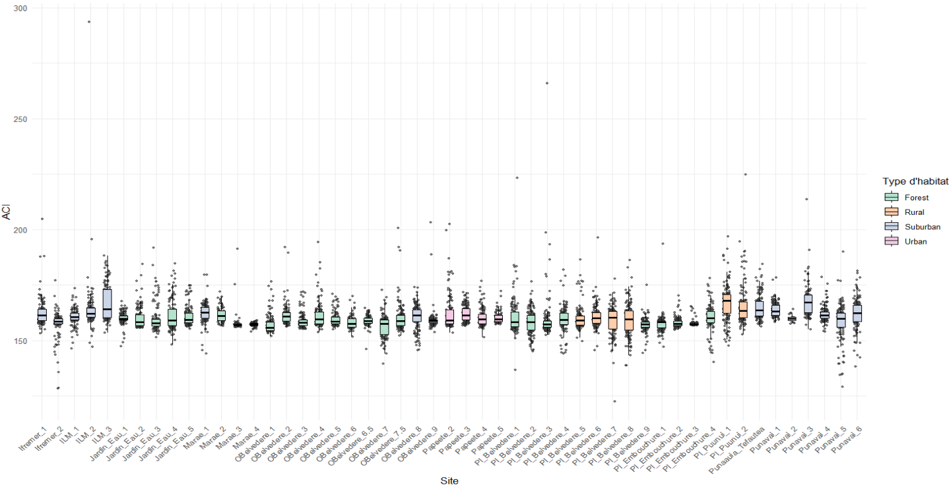

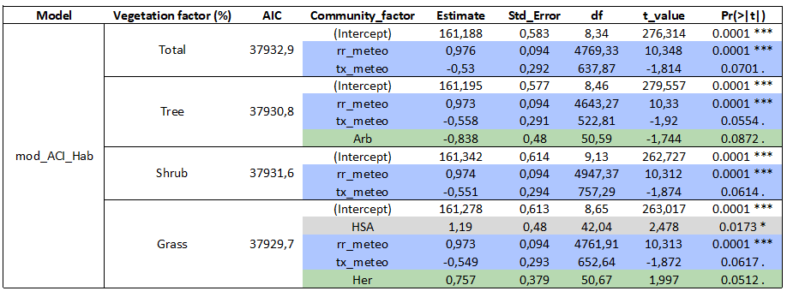
LMM ACIxHab:

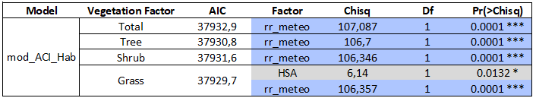
Anova ACIxHab:
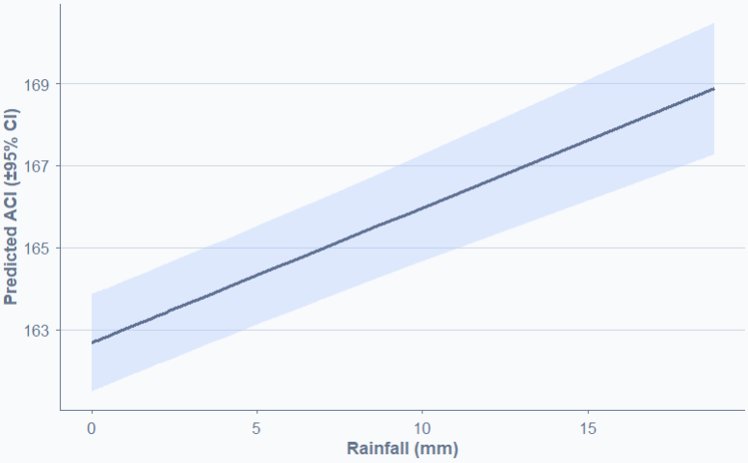
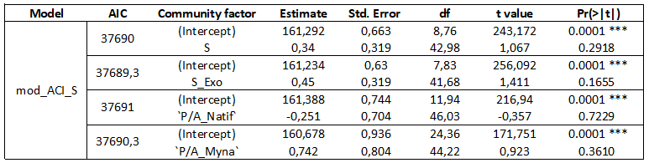
LMM ACIxS:

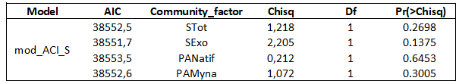
Anova ACIxS:
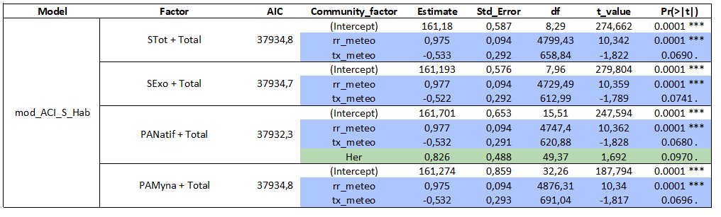

LMM ACIxSxHabtot:
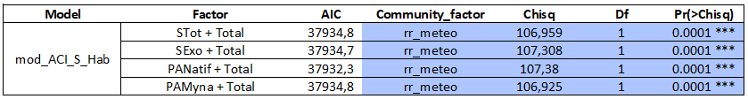

Anova ACIxSxHabtot:
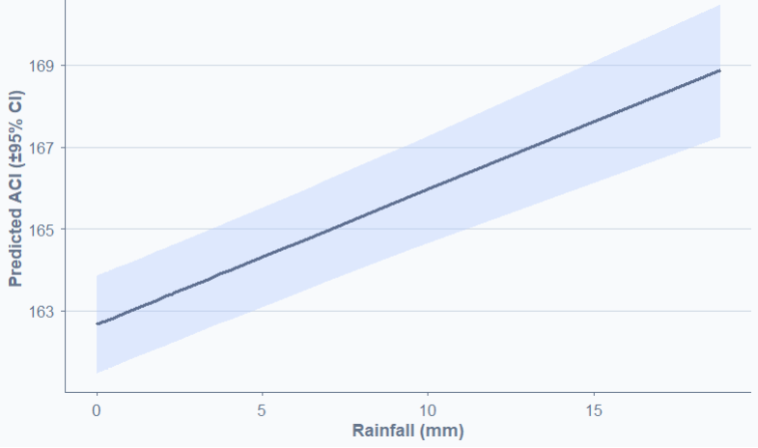
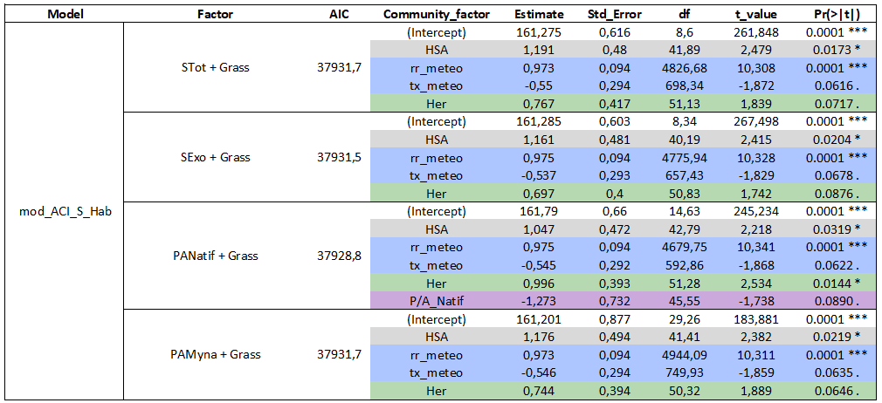

LMM ACIxSxHabam:
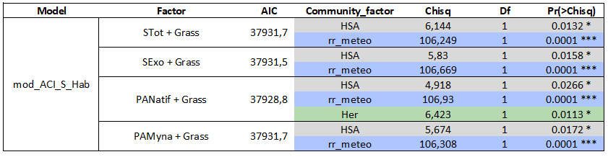
Anova ACIxSxHabam:

AEI:
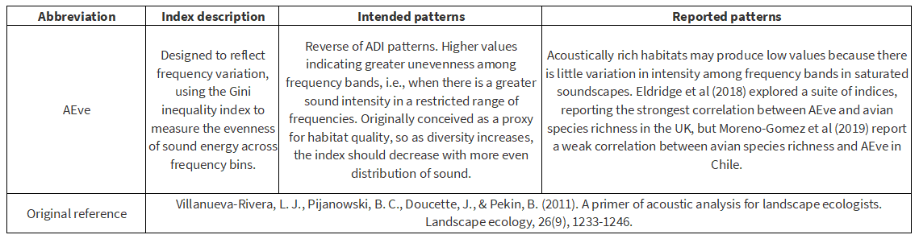
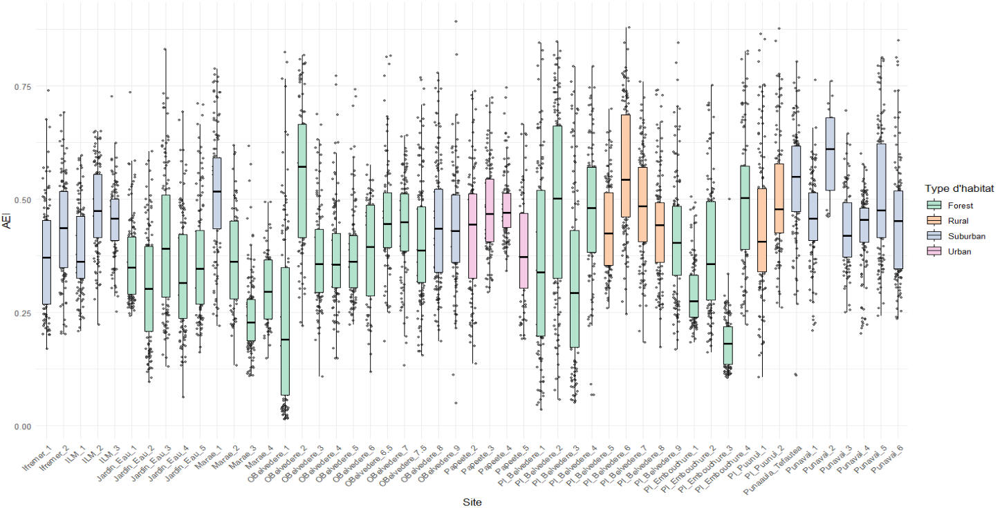

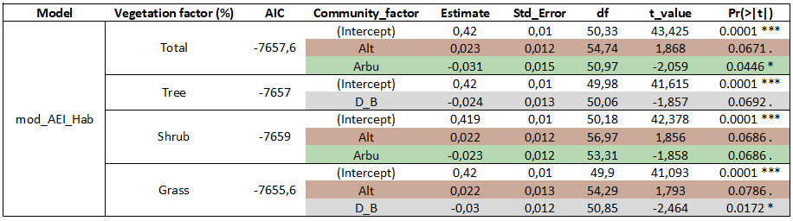
LMM AEIxHab:

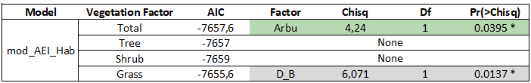
Anova AEIxHab:
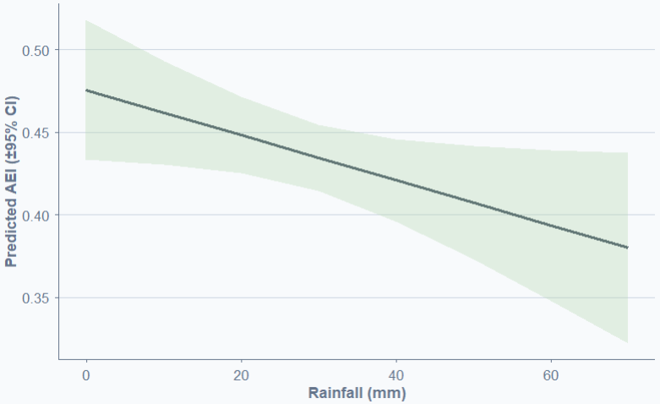
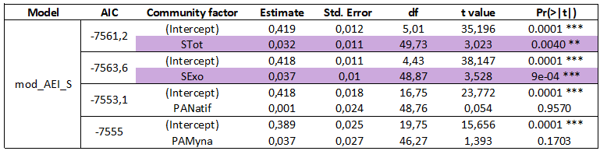
LMM AEIxS:

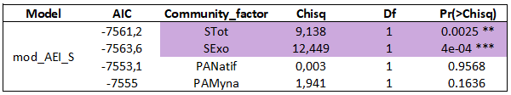
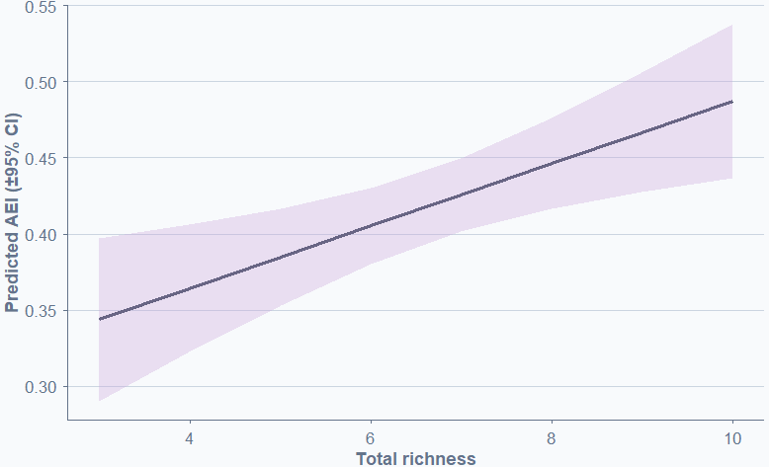
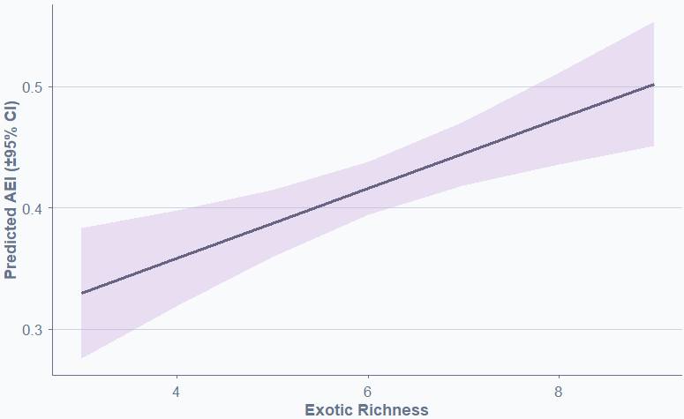
Anova AEIxS:

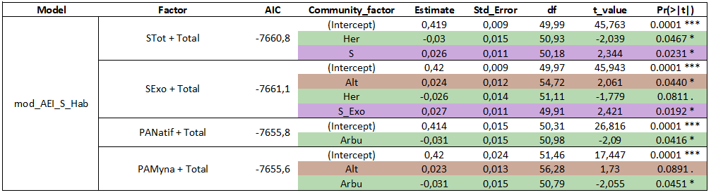
LMM AEIxSxHabtot:

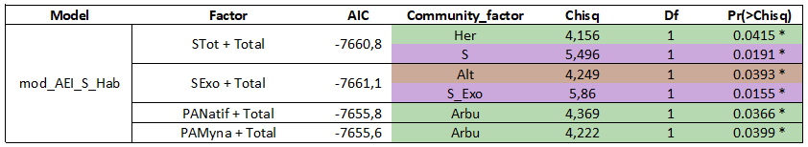
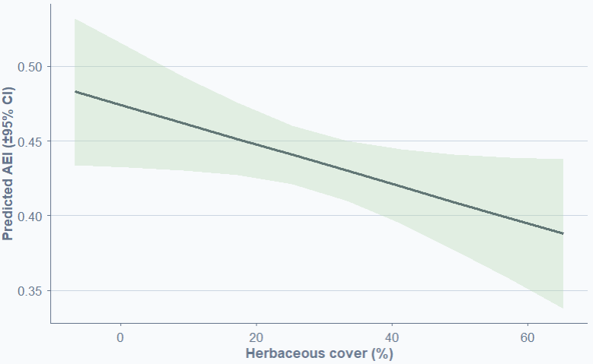
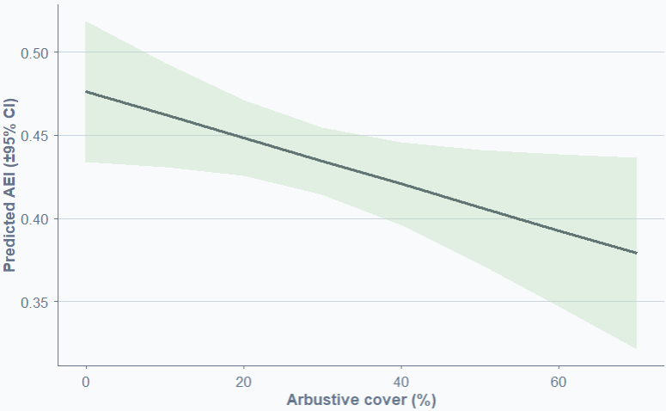
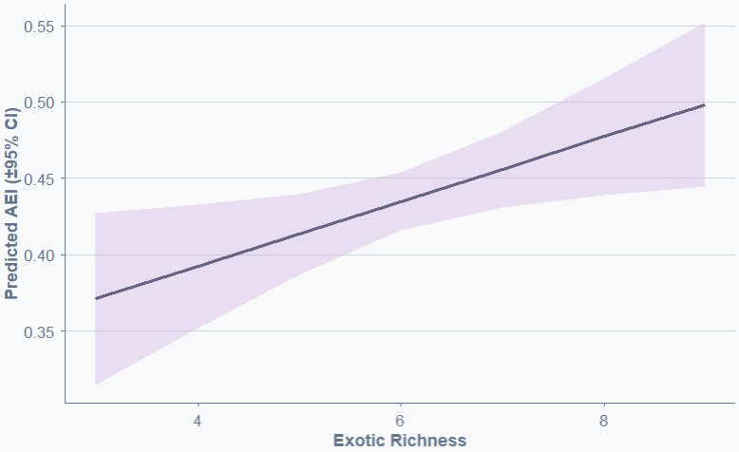
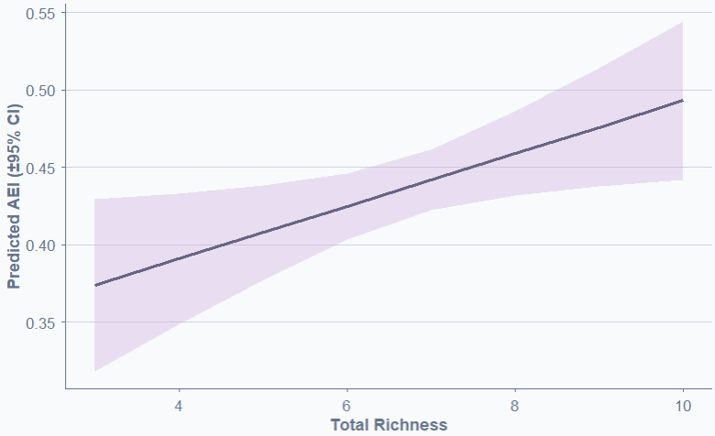
Anova AEIxSxHabtot:
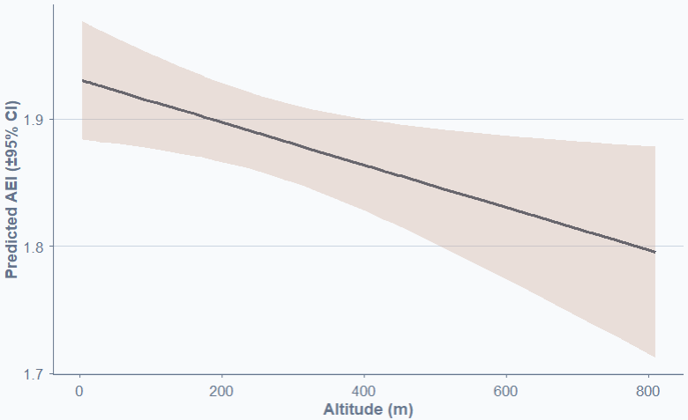
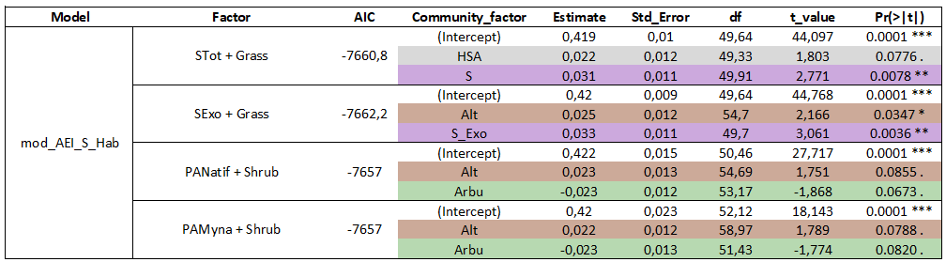
LMM AEIxSxHabam:

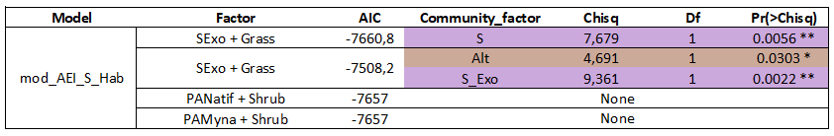
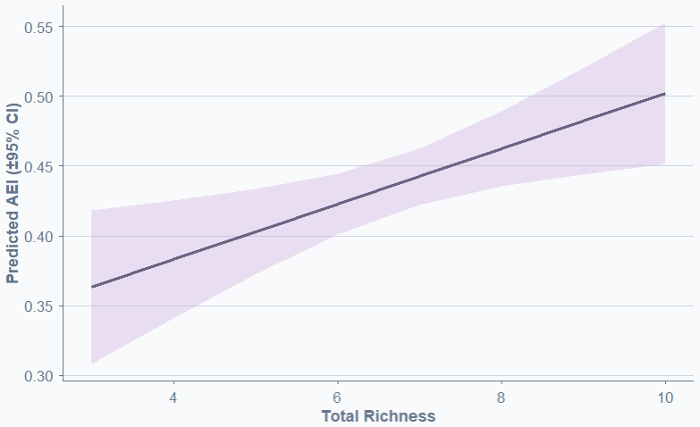
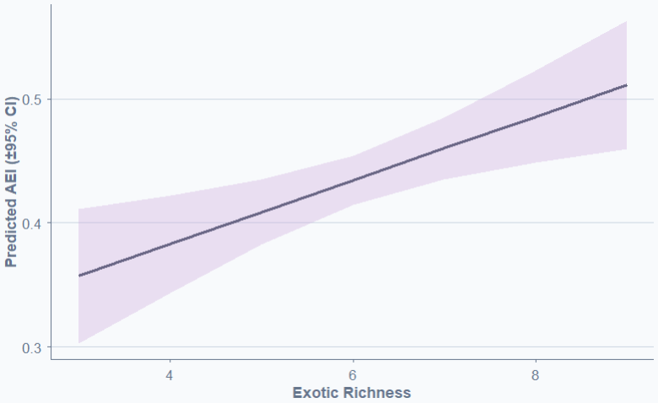
Anova AEIxSxHabam:
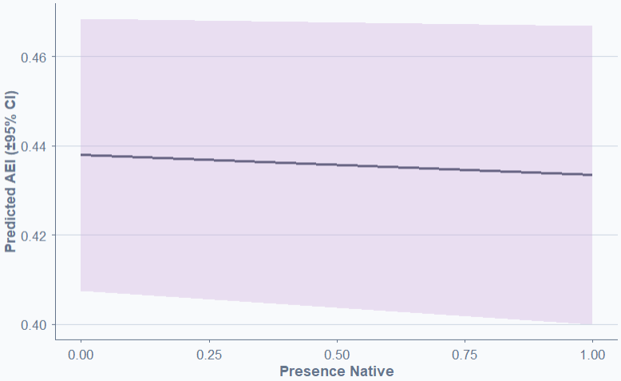
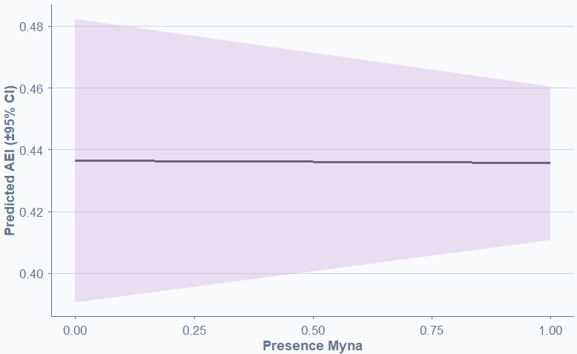

BIO:
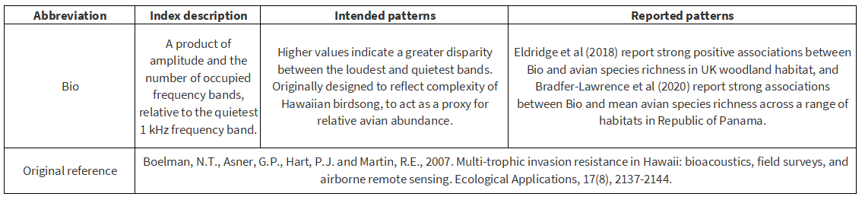
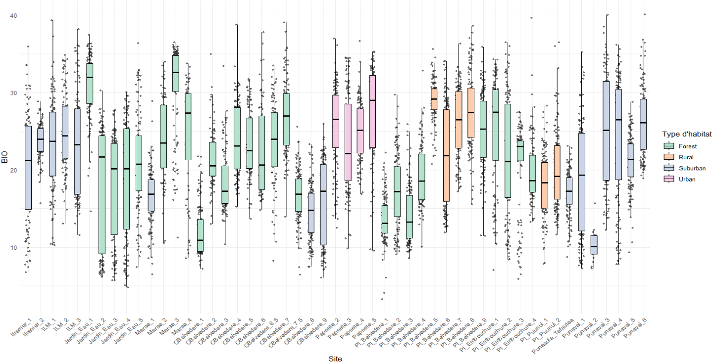

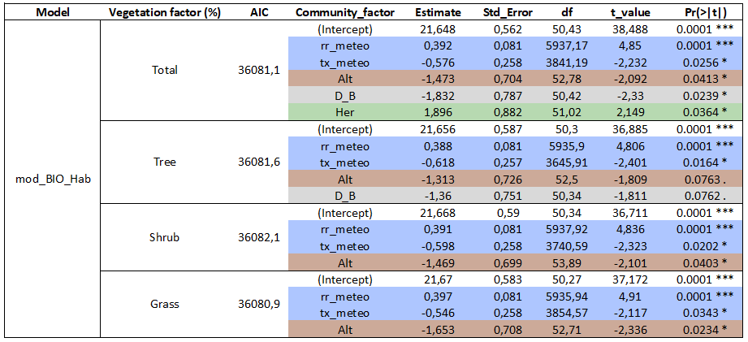
LMM BIOxHab:
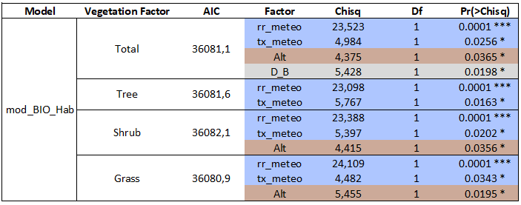
Anova BIOxHab:
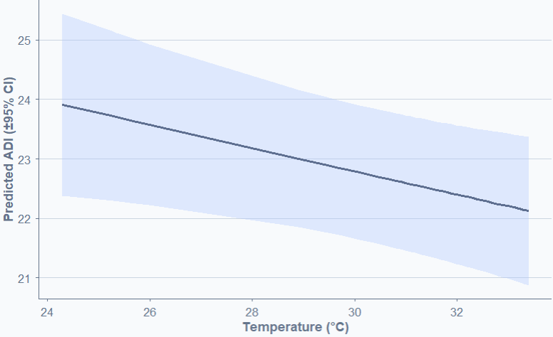
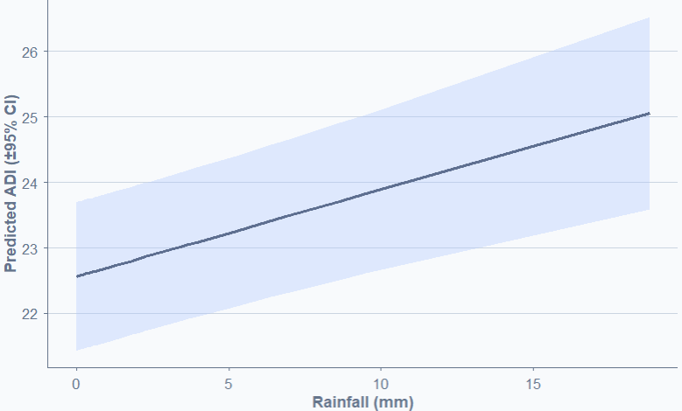
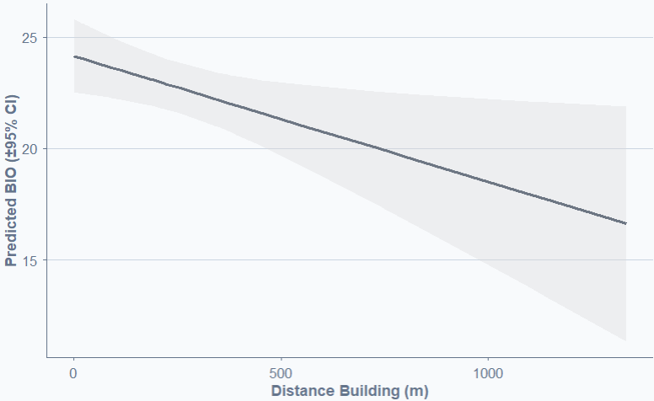
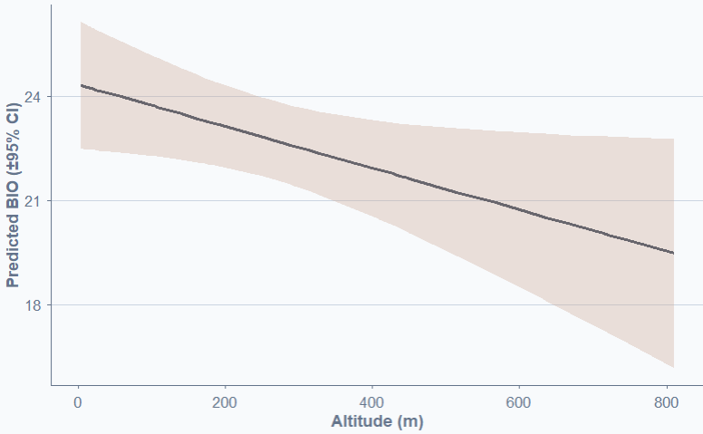
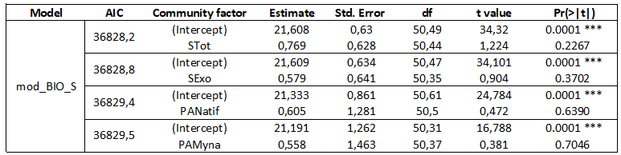
LMM BIOxS:

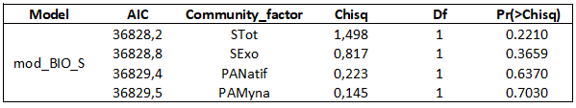
Anova BIOxS:

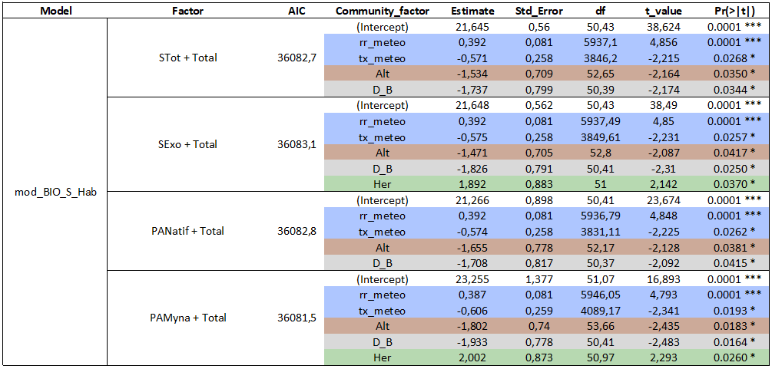
LMM BIOxSxHabtot:

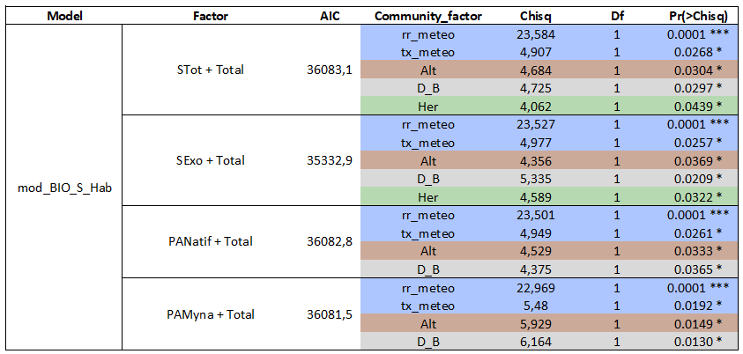

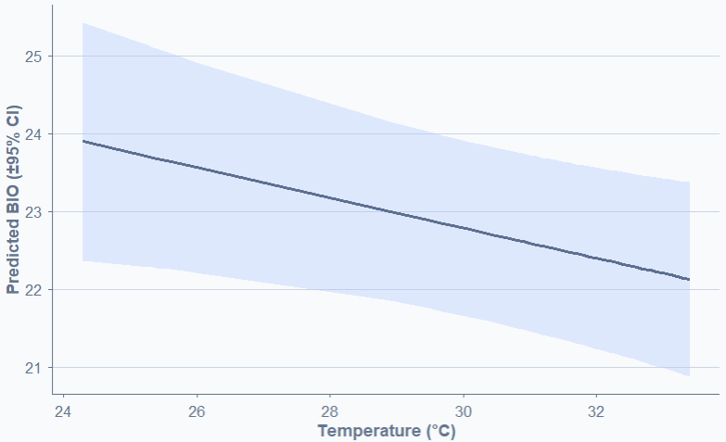
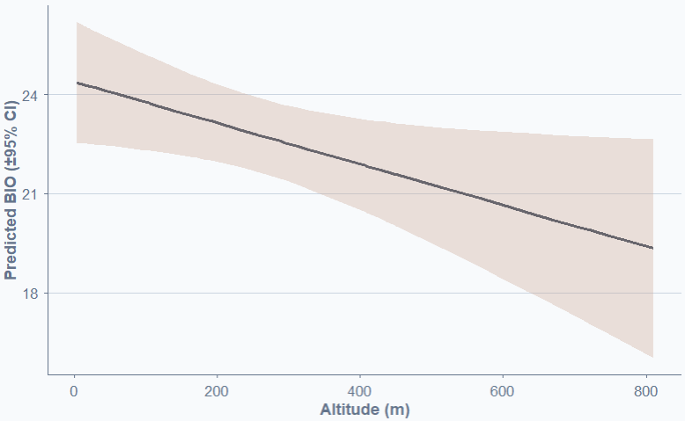
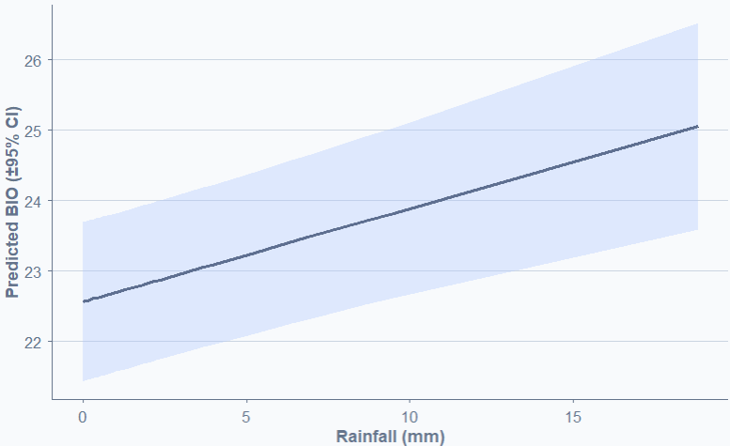
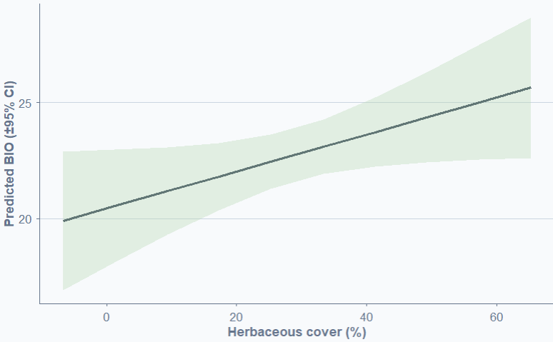
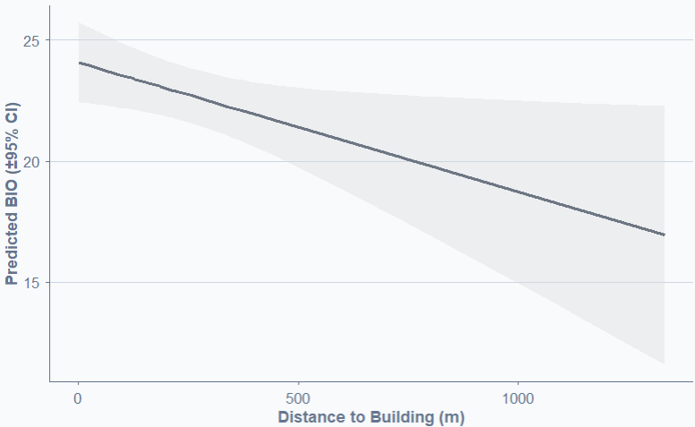
Anova BIOxSxHabtot
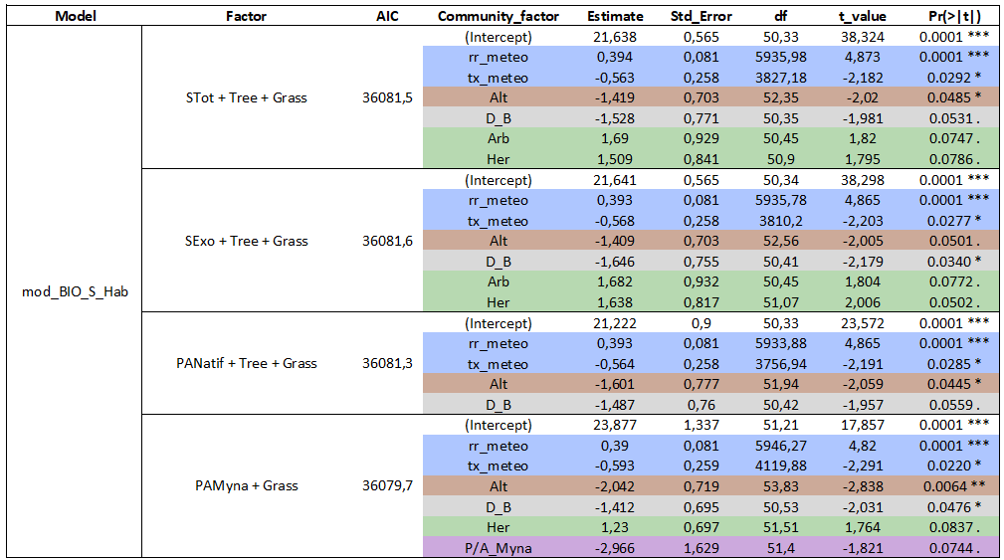
LMM BIOxSxHabam:

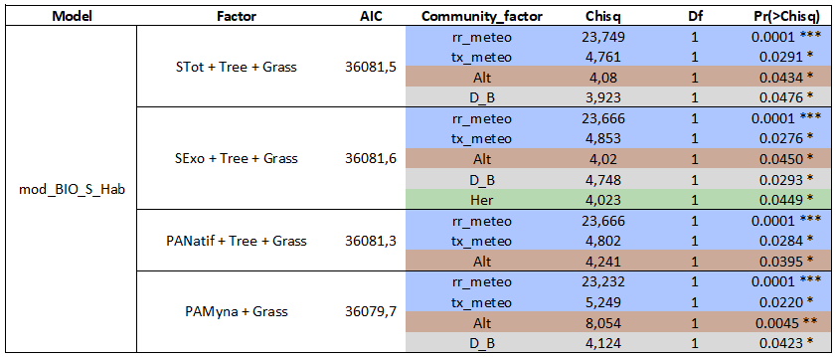
Anova BIOxSxHabam:

H:
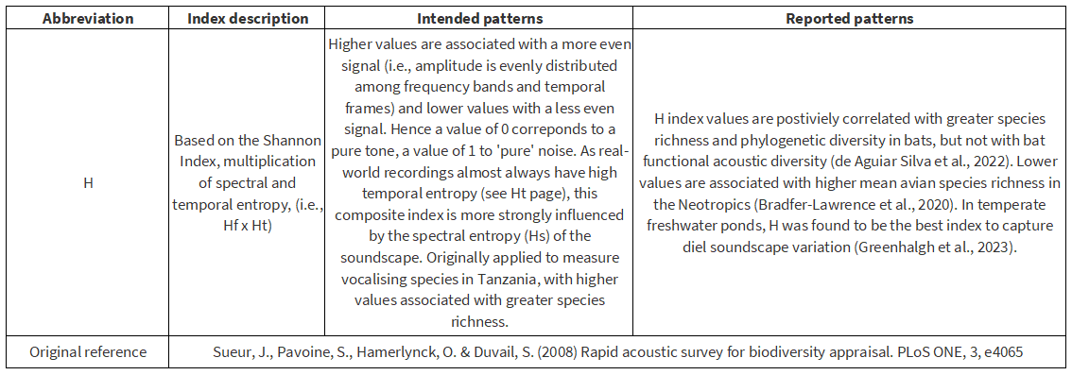
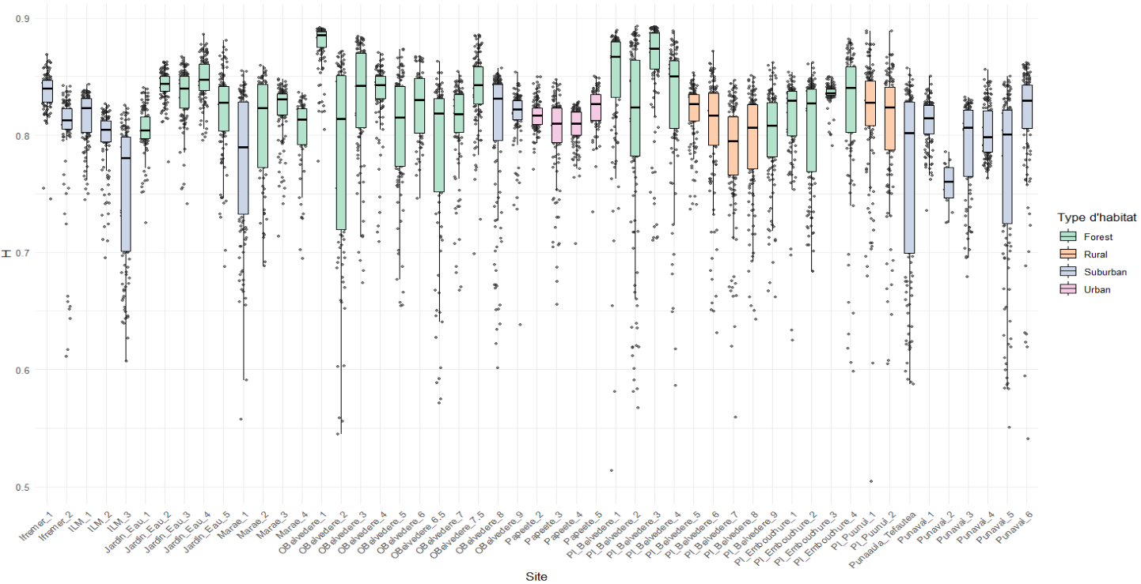

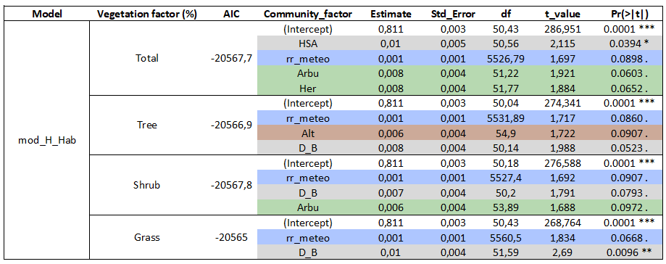
LMM HxHab:

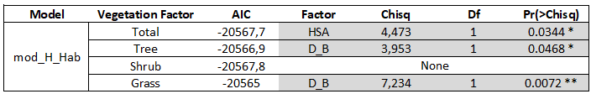
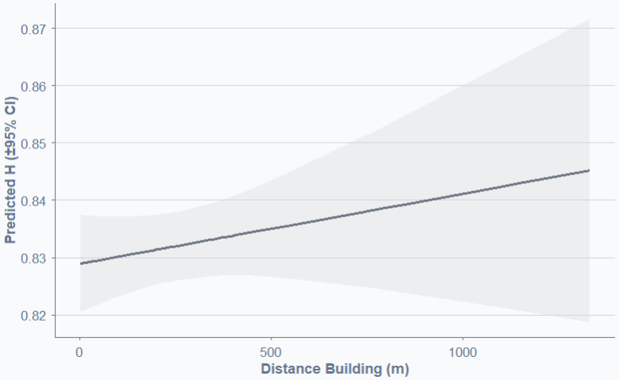
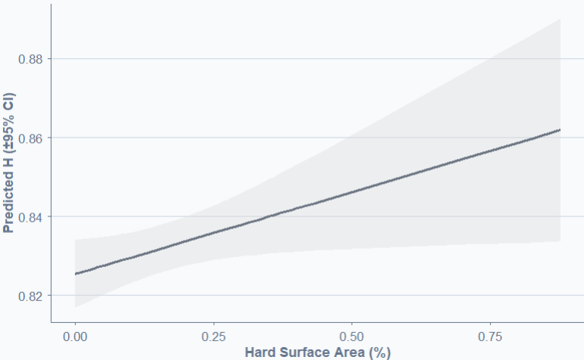
Anova HxHab:

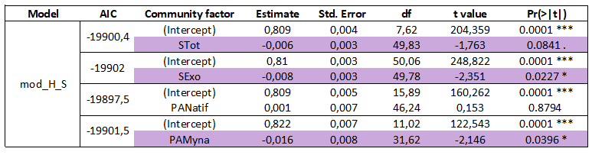
LMM HxS:

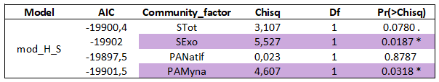

Anova HxS:
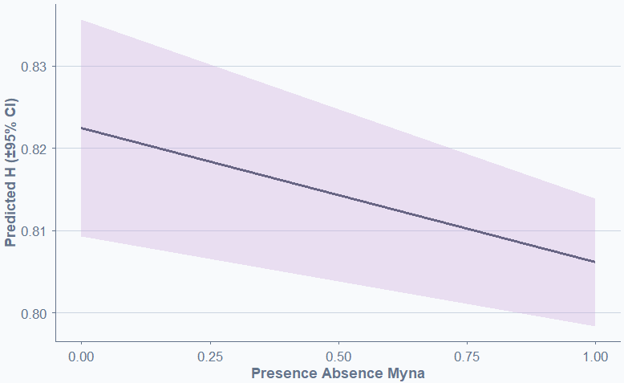
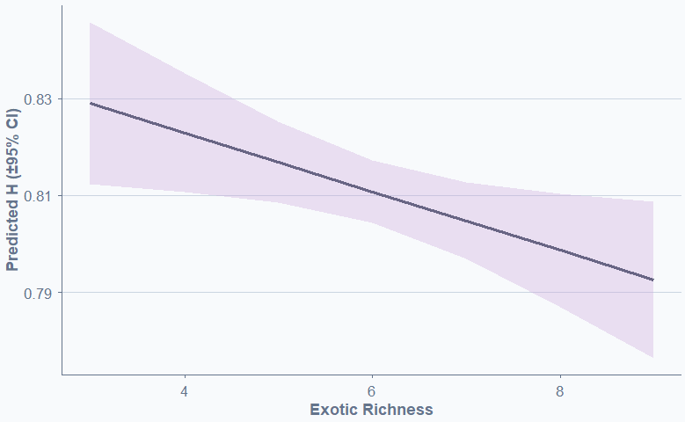

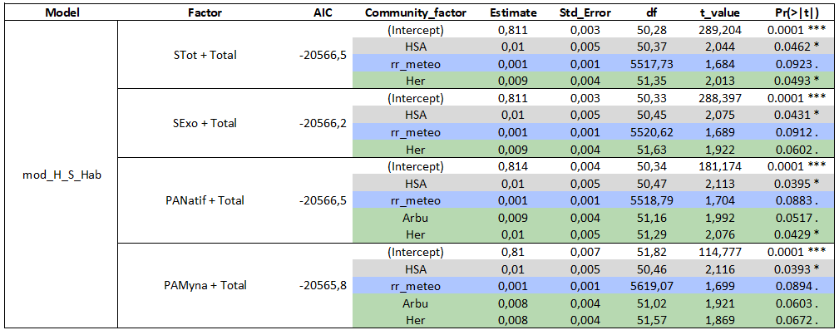
LMM HxSxHabtot:

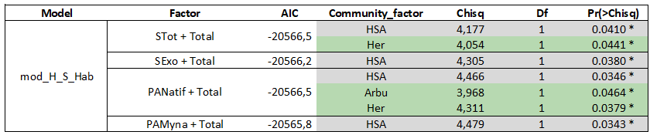

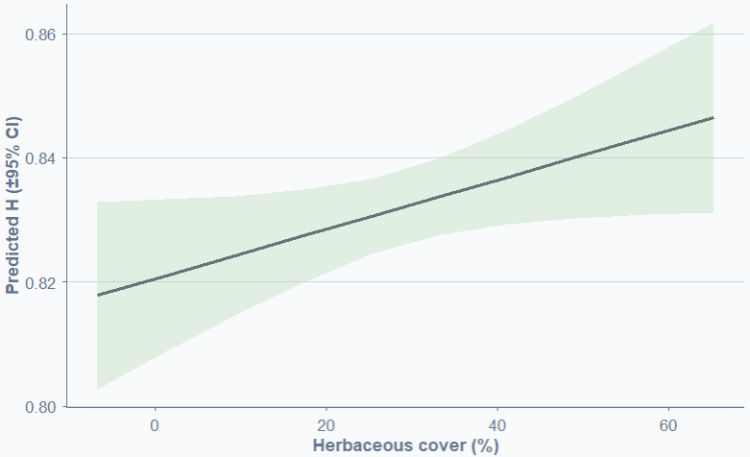
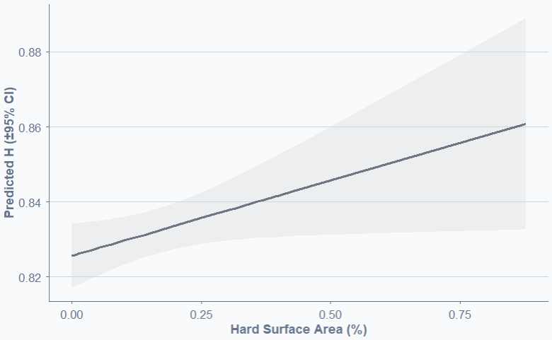
Anova HxSxHabtot:

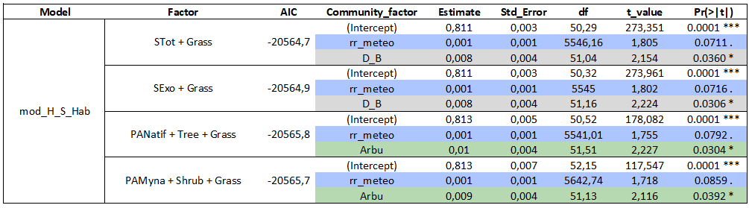
LMM HxSxHabam:

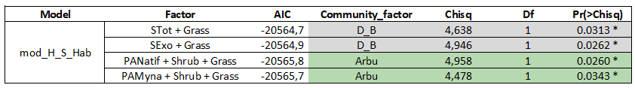
Anova HxSxHabam:

M:

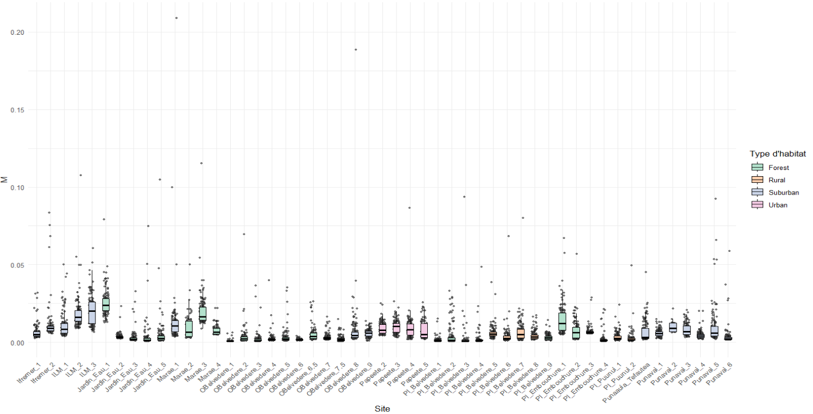
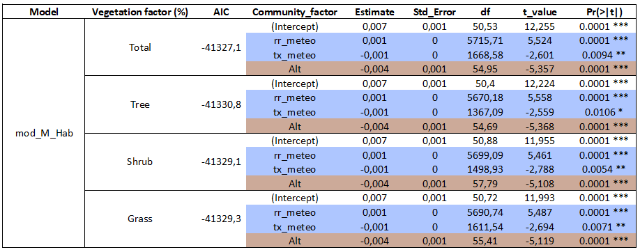
LMM MxHab:

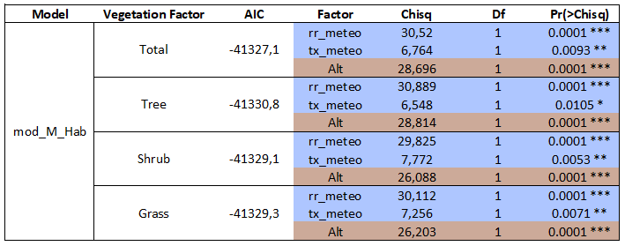
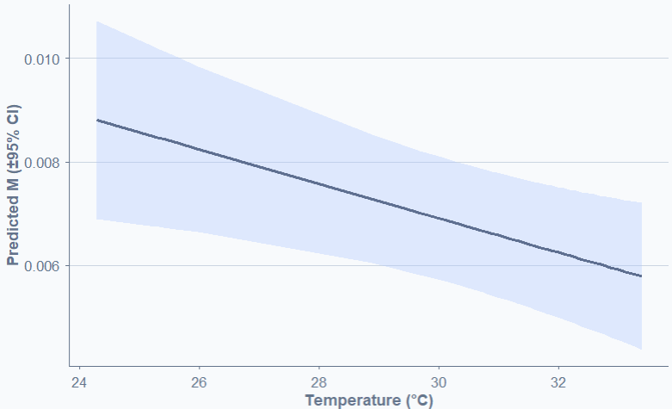
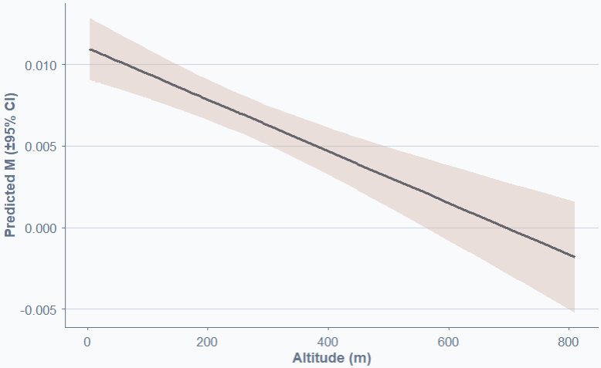
Anova MxHab:
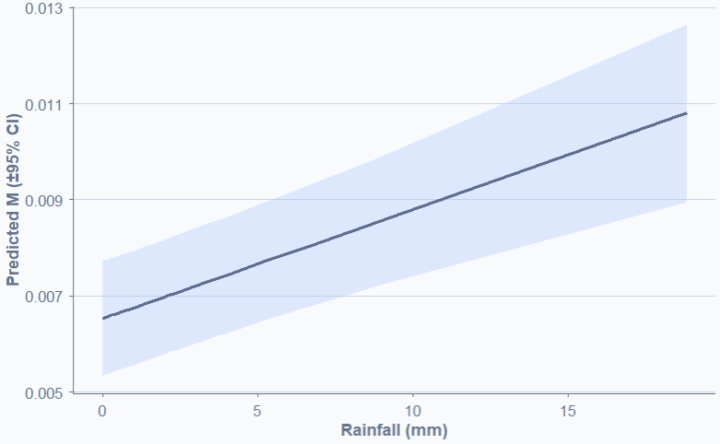
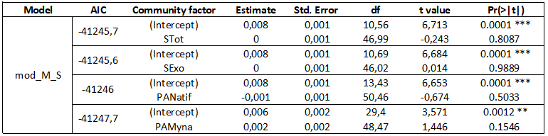
LMM MxS:

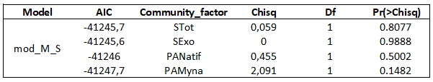
Anova MxS:

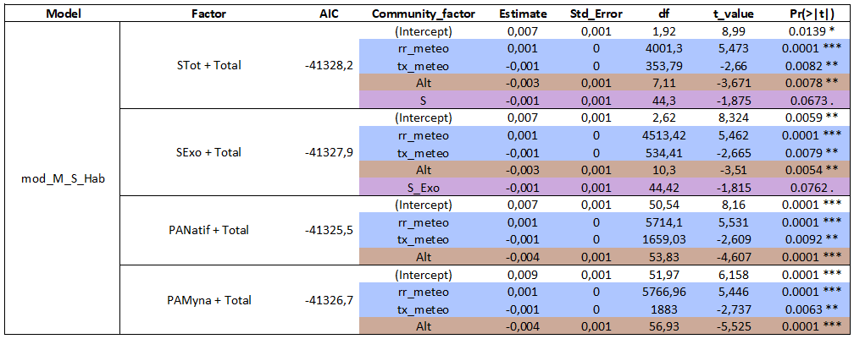
LMM MxSxHabtot:

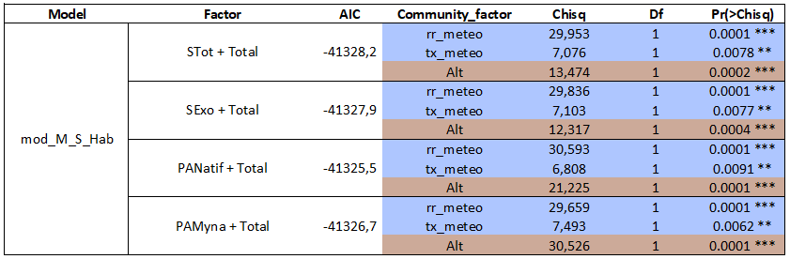
Anova MxSxHabtot:
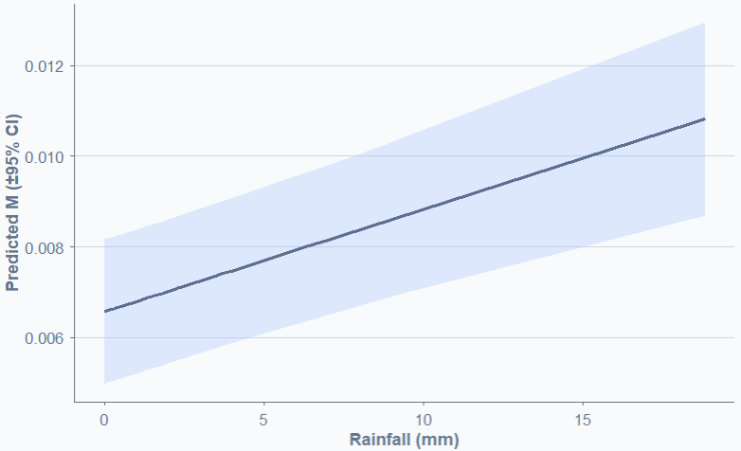
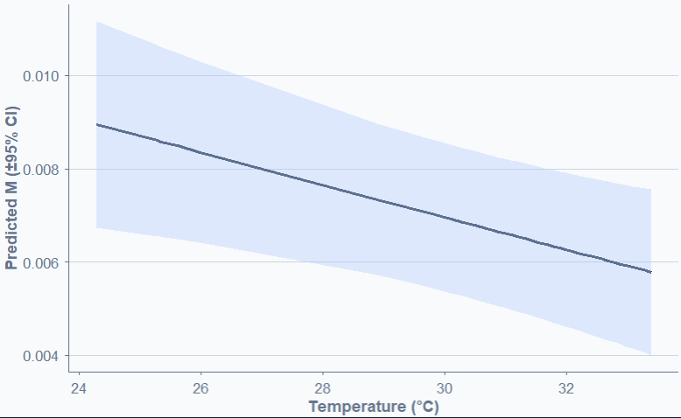
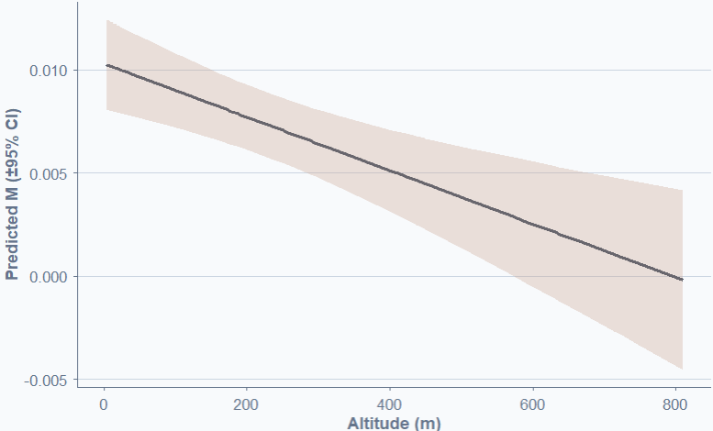

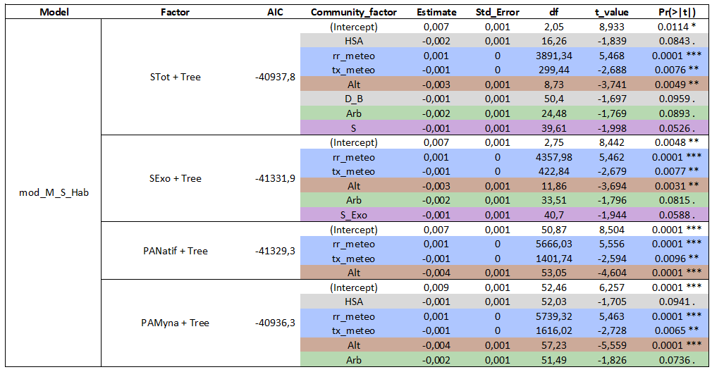
LMM MxSxHabam:

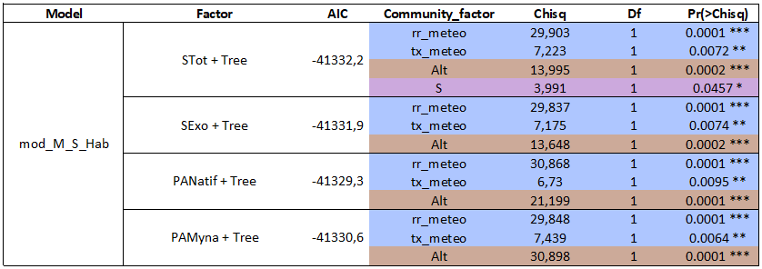
Anova MxSxHabam:

Bioacoustics: Bird Community Composition
Acoustic indices selection
Role of urbanisation gradient (UG) and avian invasive degree (AID)
Show the AID with the UG, or the different habitat type and richness.
For the point count and diversity, uses every Point count done to access, the proportion of each species in the point count and then the proportion of each species for the total number of detection.
- Proportion of terrestrial birds in point count

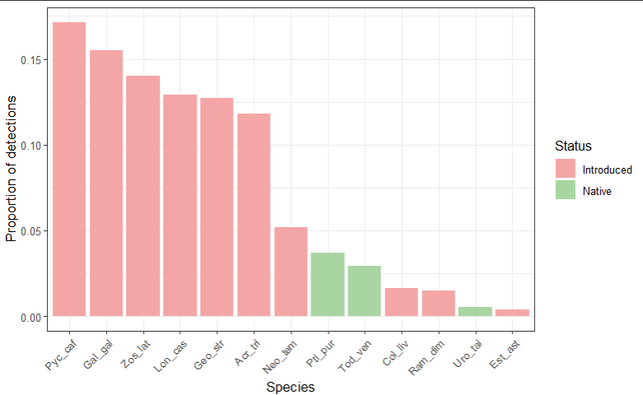
The most detected bird in the 101 point counts made matches with the detected bird in point count.

- Altitudinal and urban gradient
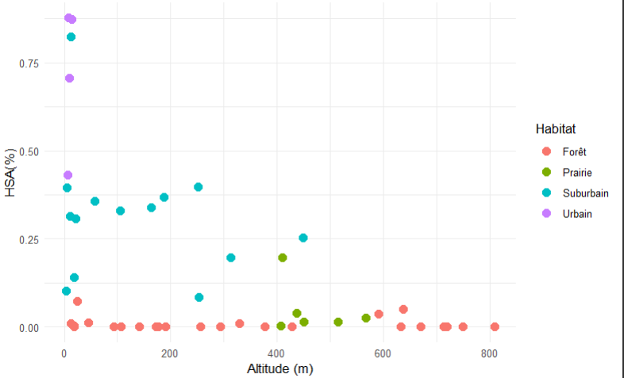
Better distributions of site via Altitudinal gradients, still a bit concentrated in minimal value. HAS value been numerous in less than <25 %. But permit to separate approximately well per Habitat type, whereas habitat x altitude not, marked by forest habitat present on the whole gradient. Disproportionate habitat type selection is marked here with four urban types for 25 forest one. With HSA, Prairie and Forest habitat are well separated from the more urban environment.

- Example of N/E proportion linked to the presence absence of Exotic species (Acr_tri)
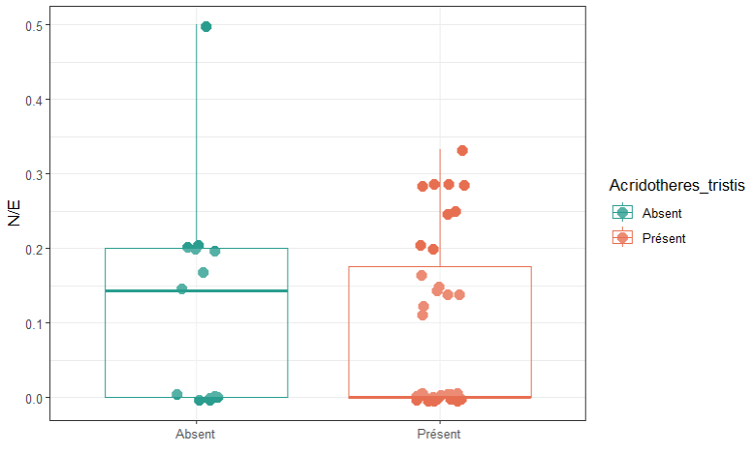
No visual pattern of Native species detection in the presence or absence of Acridotheres tristis, more native species ratio in the presence of the common Myna, but the median value is higher for absence (0.14) than presence (0), that can show for proportionate dataset, more N/E proportion in the absence of this species.

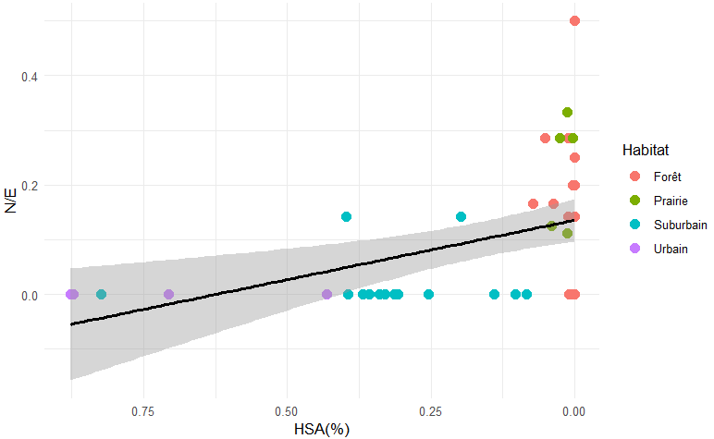
- Comparison of altitude and urban gradient using AID or S(richness) and habitat type for each site.
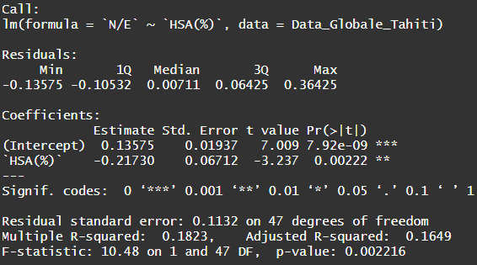

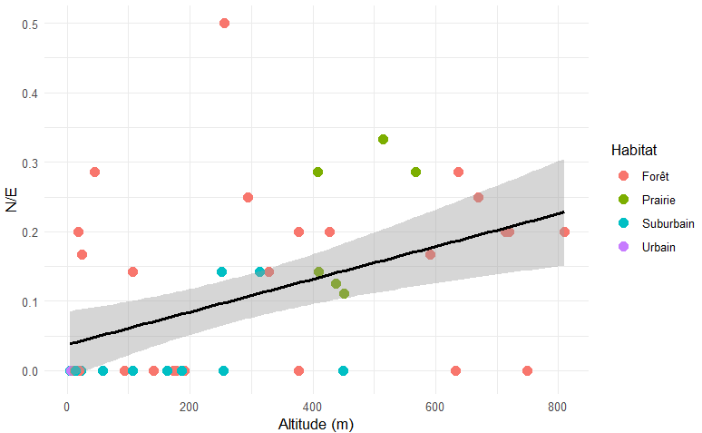
The AID pulls to the 0 for high HSA but still lacking some point to be sure. More site concentrated at 0% HSA, and bigger standard deviation when lacking site at high HAS.
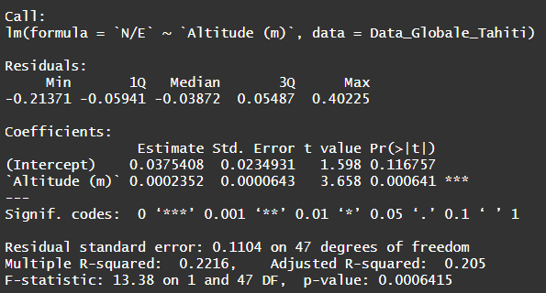

AID is pull to 0 with numerous urban, Suburban and some forest dot with low N/E proportion. Bigger standard deviation at high altitude, less site. In general, the majority of Prairie and forest site still show a relatively good N/E proportion.

The point count method is a big limit to assess the abondance and activity of bird species, working on bird species vocalisation frequencies, or the abondance of frequencies could help with precise assement. Could help with the separation of birdly invaded site and the one less invaded.
Small correlations with the r² between AID and Alt(m) or HAS(%), may so limit the interpretation with analysis using acoustic indices.

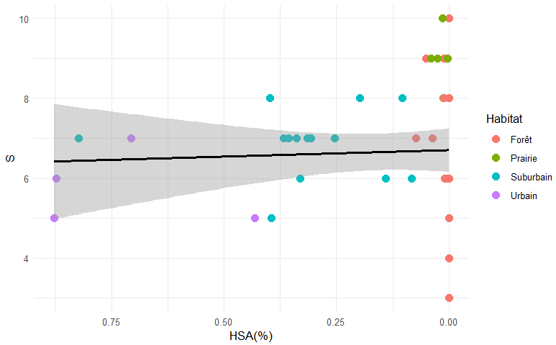
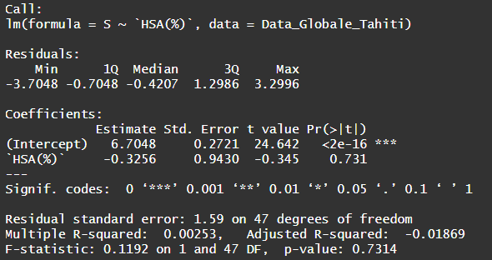

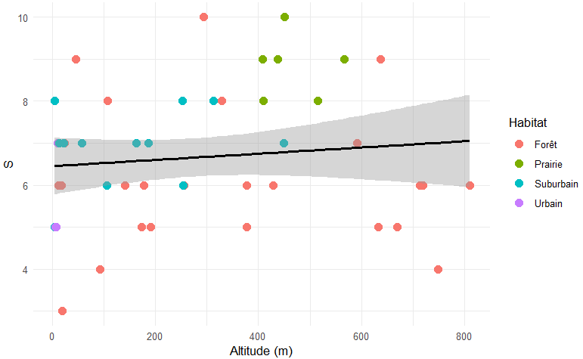
Richness estimation is not affected by urbanisation gradient, sites with low HAS seems to rather have a lot of species (exotic + native) or a lower number of species (native+fewer exotic than high urbanises). Which stabilizes the richness throughout the HAS gradient. Seems to variate a lot between sites. Every rural sites show high diversity, the other habitats are more variable.
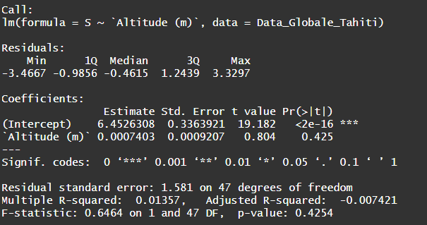

With the altitudinal gradient, sites are more disperdes for their richness. Still, sites at lower altitudes could show an average number of species with only exotic ones, then sites combining exotic and native species between 300 and 600 meter, and low diversty site with onlynatives species and few exotic ones.

Richness is not correlated with altitudes or HAS gradient in our datasets.
The definition of the habitat types could be more precised, as some urban and suburban sites are quite mixed. Using only two habitats type could me more precised.

- Barplot of each Habitat type with HSA or fused in only two, with AID

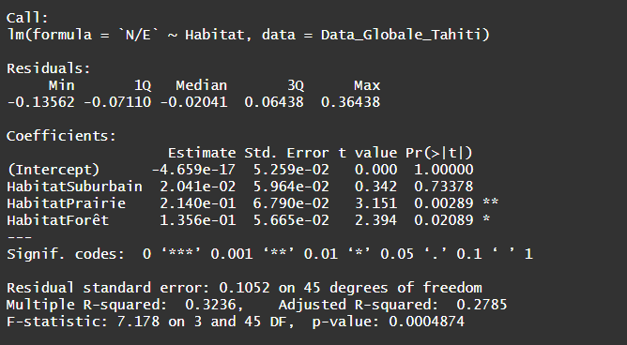
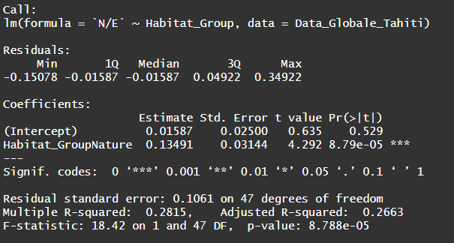
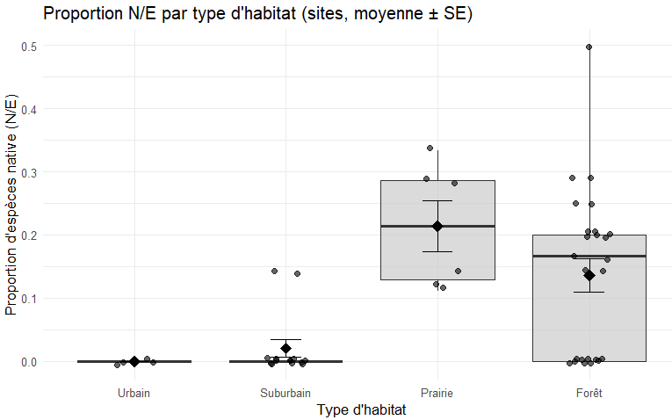
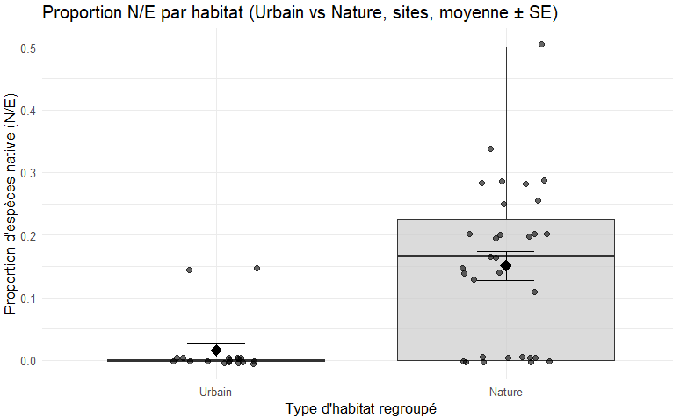
With the linear models, test significantly show two group within the habitat types

Mean and median value are higher and similar for natural habitats types, wheres Urban an Suburban are very restricted in native’s species.
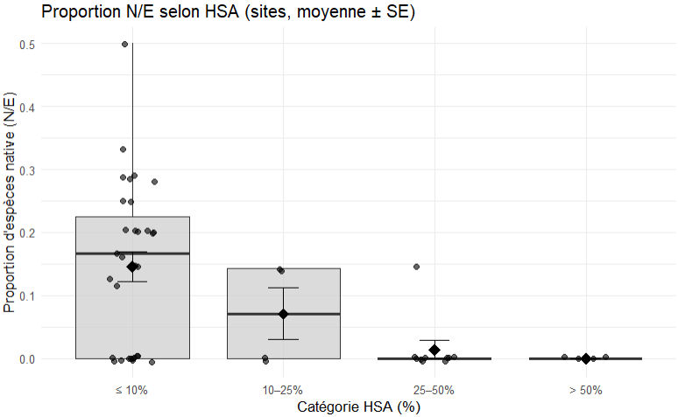
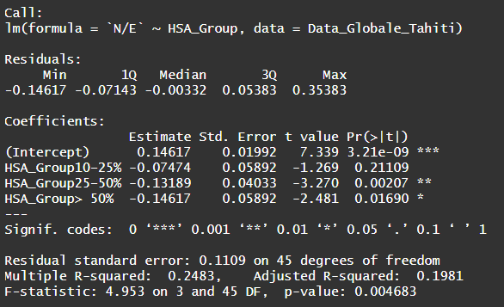
Here the same is described using HAS values, this will permit to explain distinct types of pattern with acoustic indices using HAS on the absicce (x). That could be related to presence or absence of native species

Mean of the acoustic indice for the hour, based on the 5-minute sample
- Means of each acoustic indices (x6) per site with altitudinal and urban gradient, richness and avian invasion degree. Une droite par indices.
- Barplot per site, habitat separated in two, with the mean of each indices. (x6 graph)
- A graph with for each indices, on temporal gradients to look at pattern of each indices, in general and maybe separated with urban and natural sites (milieu type). With standardisation 0-1 and standard deviation. Needs to find a way to have the good files for the good hour for each sites, which differs quite a lot. (x6 graph)

Discussion
Compare distribution of sounds between highly invaded and low invaded island, spatially and temporally
With good quantification of frequency of sounds in recorders we could look for pattern in high and low propotion of invasive species.
Pourrait pour certains indices les plus pertinents mettre en avant la corrélation de ces indices avec la richesse ou le AID !!!
Quels différence à utiliser entre un T test classique et un wilcoxon quand on compare le sincides en Bar plot pour un indice type ?.
Limitation : Small number of acoustic indices, classical one.
Duration of recording were also quite short, still the variance in our indices are correct.

Bibliography Traitement des données, on se base sur l’article suivant :
Bradfer-Lawrence T., Gardner N., Bunnefeld L., Bunnefeld N., Willis S.G., et Dent D.H. 2019. Guidelines for the use of acoustic indices in environmental research. Methods in Ecology and Evolution, 10(10), p. 1796-1807. DOI : 10.1111/2041-210X.13254
Choksi P., Kotian M., Biniwale S., Mourya P., Korche D., Agarwala M., Khanwilkar S., Ramesh V., et DeFries R. 2023. Listening for change: quantifying the impact of ecological restoration on soundscapes in a tropical dry forest. Restoration Ecology, 31(4), p. e13864. DOI : 10.1111/rec.13864
Song Z., Yang Z., Xiong Y., et Yang Y. 2025. Assessing the drivers of bird diversity in urban parks during winter: Insights from acoustic indices. Ecological Indicators, 178, p. 113854. DOI : 10.1016/j.ecolind.2025.113854
Rogers A.M., Griffin A.S., Lermite F., van Rensburg B., Archibald C., et Kark S. 2021. The role of invasion and urbanization gradients in shaping avian community composition. Journal of Urban Ecology, 7(1), p. juab030. DOI : 10.1093/jue/juab030
Fairbrass A.J., Rennert P., Williams C., Titheridge H., et Jones K.E. 2017. Biases of acoustic indices measuring biodiversity in urban areas. Ecological Indicators, 83, p. 169-177. DOI : 10.1016/j.ecolind.2017.07.064
Farina A., Pieretti N., et Piccioli L. 2011. The soundscape methodology for long-term bird monitoring: A Mediterranean Europe case-study. Ecological Informatics, 6(6), p. 354-363. DOI : 10.1016/j.ecoinf.2011.07.004
Villanueva-Rivera L.J., Pijanowski B.C., Doucette J., et Pekin B. 2011. A primer of acoustic analysis for landscape ecologists. Landscape Ecology, 26(9), p. 1233-1246. DOI : 10.1007/s10980-011-9636-9
Boelman N.T., Asner G.P., Hart P.J., et Martin R.E. 2007. Multi-Trophic Invasion Resistance in Hawaii: Bioacoustics, Field Surveys, and Airborne Remote Sensing. Ecological Applications, 17(8), p. 2137-2144. DOI : 10.1890/07-0004.1
Sueur J., Pavoine S., Hamerlynck O., et Duvail S. 2008. Rapid Acoustic Survey for Biodiversity Appraisal. PLOS ONE, 3(12), p. e4065. DOI : 10.1371/journal.pone.0004065
Depraetere M., Pavoine S., Jiguet F., Gasc A., Duvail S., et Sueur J. 2012. Monitoring animal diversity using acoustic indices: Implementation in a temperate woodland. Ecological Indicators, 13(1), p. 46-54. DOI : 10.1016/j.ecolind.2011.05.006
Kasten E.P., Gage S.H., Fox J., et Joo W. 2012. The remote environmental assessment laboratory’s acoustic library: An archive for studying soundscape ecology. Ecological Informatics, 12, p. 50-67. DOI : 10.1016/j.ecoinf.2012.08.001
Fuller S., Axel A.C., Tucker D., et Gage S.H. 2015. Connecting soundscape to landscape: Which acoustic index best describes landscape configuration? Ecological Indicators, 58, p. 207-215. DOI : 10.1016/j.ecolind.2015.05.057

